1.0 introduction
This document describes the test methods and equipment capability requirements to be used to verify that the electronic and electrical modules, sensors and switches satisfy the component level, full vehicle environmental requirements as detailed in the EESYS EY-0128.
NOTE: any DUT that does not meet any requirement stipulated in any of the various evaluations shall be considered a failure and removed from test at the time of the discovery of the non compliance. An 8D shall be started and the Ford D&R engineer shall be informed of the non compliance within 24 to 72 hours of the discovery.
At no time shall failed/non compliant/suspect DUT be put back into or allowed to continue the test.
1.1 COMMONALITY. This is a CONTROL TEST and it shall be used to verify the robustness and compatability of electronic and electrical modules, sensors and switches to the 99th percentile Customer vehicle environmental requirements found throughout the world. The test may be conducted at any location having the necessary equipment and facilities. Proposed revisions to this procedure must be submitted per FAP03-179.
1.2 APPLICABILITY. Applicability of test is as specified in EESYS/EY0128 and by the Vehicle Program Team. The component/unit/device being tested will be referred to herein as the Device Under Test (DUT).
NOTE: the ASAP Procedure 3.0 may be used in place of this procedure.
1.3 ACCEPTANCE REQUIREMENTS. Acceptance of each DUT’s shall be based on , the evaluations described in Table6.2,, the performance requirements described in Table 6.3and any applicable Design Verification Methods listed in the various SDSs that use this CETP..
1.4 SAMPLE SIZE.. The minimum sample size for group A shall be12, for group D 8 and for all the rest the samples size shall be 6. If reworked parts are to be included in the tests the sample sizes shall be doubled with the additional samples being reworked parts.
The Drop test (6.4.6.3), requires 14 samples and the Chemical Resistance, 6.4.7.2, test may require additional samples depending on the number of chemicals required.
These sample sizes have been deemed sufficient due to the level at which each test environment has been set, that of the 99th percentile customer for the most severe vehicle application.
Note: Ford Motor Company/N.A. no longer sets Reliability and Confidence targets for most of its components/modules nor does it employ them in the selection of sample sizes for most of its tests.

Our validation paradimn is based on Strength of Test, Customer Usage Requirments and Mistake Proofing. Additional samples may be stipulated by the responsible D&R engineer if there are legal or process quality requirements that dictate their use. HALT ( 6.4.8.5) testing may require a larger sample size if the determination of Destruct limits is stipulated.
1.5 SEQUENCE OF TESTS. Test shall be done serially in the order specified in groups defined in table 6.4 or as agreed to by the supplier and the Ford D&R and Reliability/Test engineers.
1.6 MICROPROCESSOR REQUIREMENTS. The DUT’s MUST have a production representative microprocessor/memory device. In addition a vehicle representative strategy shall be used. The software should be in a typical operating mode (i.e., not in idle or standby mode). Test software is allowable for DV testing but not for PV.
1.7 DELIVERABLES
1.7.1 PRE-DV DELIVERABLES
The Supplier will deliver to the Ford D&R Engineer the following:
1) Signed off WCCA
2) HALT test results with 8Ds of any failiures/descrepencies
3) Performance Evaluation and Monitored Operation requirements with what's being measured, loads being used and their acceptance criteria. These shall be compared to the Ford Design (SDS) requirements and any discrepencies will be highlighted and explained.
4) Planned End of Line test measurements and how they correlate to the Ford Design requirments (SDS). A list of requirements that are not being checked at end of line shall also be included with the reasoning as to why not.
5) DVP with timing and sample sizes.
6) Will parts be reworked? If yes ½ of test samples need to be reworked parts. The supplier and the Ford D&R will determine what reworks will be included in the test.
7) Supplier shall provide evidence that all components used in their DUTs meet the 1000 hour 85% humidity, 85 degree Celcius requirement. No components may be used in a Ford product that do not meet this requirement.
8) Submit a copy of the Reflow, Wave, and / or Selective Solder Machine temperature profile with written verification that the profile meets the solder and all component manufacturers thermal requirements
1.7.2 DV DELIVERABLES
Within two weeks of the DV test completion the following shall be supplied to the Ford D&R engineer:

1) Completed DVP&Rwith test data summary and pictures of solder sections/inspections.
2) Copy of the test log signed by the supplier test and design engineers
3) All 8Ds for any failures/descrepencies.
4) Rolled Through Put Yield for DV run
5) Results of a study of the micro strain the board experiences during the prototype build process and a comparison to those required by the parts. The strain measured must not be within more than 75 % of that required by the parts.
6) If boards are built on the production process provide Cleanliness Measurement data on incoming bare boards and as they come out of the solder process(s). Suggested method are those recommended by the IPC or equivalent. Results to be reported in mg/ sq cm and by element content.
1.7.3 PRE PV DELIVERABLES.
1) Final End of Line test measurements and how they correlate to the Ford Design requirments (SDS). A list of requirements that are not being checked at end of line shall also be included with the reasoning as to why not along with the tester fail safe strategy.
2) PVP with timing and sample sizes.
3) Copy of the Control Plan with a list of planned Audits
4) List of any open issues.
5) List of what reworks will be included in the test samples.
6) Submit a copy of the Reflow, Wave, and / or Selective Solder Machine temperature profile with written verification that the profile meets the solder and component manufacturers thermal requirements
1.7.4 PV DELIVERABLES
1) HALT test results with 8Ds for any failures/discrepencies.
2) Completed PVP&R with data summary and pictures of solder sections/inspections.
3) Copy of the test log signed by the supplier test and design engineers
4) All 8Ds for any failures/discrepencies
5) Audit results with the Ppks for each significant characteristic.
6) List of recommendations of IP tests based on PV results.
7) Results of tester validation and fail safe verification

8) Rolled Through Put Yield for PSW run. If less than 99% a plan shall accompany the data with steps to improve the yields to 99%.
9) Results of a study of the micro strain the board experiences during the production build process and a comparison to those required by the parts. The strain measured must not be within more than 75 % of maximum that is required by the parts.
10) Provide Cleanliness Measurement data on incoming bare boards and as they come out of the solder process(s). Suggested method are those recommended by the IPC or equivalent. Results to be reported in mg/ sq cm and by element content.
1.7.5 POST PV DELIVERABLES
1) For the first year of production, once every 30 days the current Rolled Through Put Yield shall be sent to the Ford D&R and STA engineers as well as the status of the plan to improve the yield to 99% if not already there.
2) For the first year of production, once per quarter run a HALT Operation Limit test to the PV operation limits and supply results to the Ford D&R and Reliability engineers along with 8Ds for any failures/non compliances.
3) For as long as the DUT is in production the supplier will monitor the Warranty and TGW performance and request part returns from the field through the Ford D&R engineer. All returns will be root caused and 8Ds written for each. If there are any TNIs (Trouble not Identified) then the supplier will follw the TNI procedure in section 6.4.1.
1.7.6 RETENTION OF TEST SAMPLES
All samples used for DV and/or PV evaluations, testing or held as 'golden unit' during the tests shall be available for Ford inspection/evaluation for one year after the Job 1 date for each vehicle line application.
2.0 Instrumentation
2.1 GENERAL TEST. Setup and Fixtures.
2.1.1 Equivalency. Unless otherwise specified, equivalent equipment may be used.
2.1.2 The device under test shall be tested with the subsystem or system configuration, as applicable.
2.1.3 Grounding. In general, all inputs and outputs, including power, shall be referenced to a single point ground.
2.1.4 Temperature. The device under test (and mounting fixture if used) will be completely surrounded by an envelope of air. The temperature of the envelope of air will be ± 2 °C of the test temperature. This temperature is to be measured and verified 2.5 cm from the component under test and at nonoperating conditions and pre test temperature balance data shall be recorded in the test log.
If a still air test is deemed necessary due to the vehicle application see CETP 15.01-L-400.
2.1.5 Pre & Post test checks. The component will be checked prior to and immediately after each test as specified in section 1.3 above. These data are to be recorded along with the component and test identification number and test history. It is required that a the test log or record be created that will include:
a. The input/output signals to be monitored during and after each test. Refer to tables 6.2 and 6.3 for definition of the key parameters to be monitored and any permissible degradation of signal level that may be allowed shall be defined by the Ford D&R engineer.
b. Identification of all test equipment, including but not limited to identification of all thermal, salt, dust, water chambers, vibration test equipment along with the temperature balance data recorded for each before the start of test as required in section 2.1.4.
c. All recorded data.
d. All discrepancies and 8Ds.
e. Sign off at test completion by the test and design engineers.
- Temperature monitoring. Identify the point or points on the module/board that will be used to monitor temperatures/accelerations for the various tests below.
NOTE: Copy of test signed test log shall accompany the D/PVP&R given to the Ford D&R engineer, may be in hard copy , disc or data file format.
2.2 INTERCONNECTIONS. DUT’s shall be connected in a subsystem configuration to represent the vehicle system as much as is practical. In order to maximize the usefulness of all testing the test fixtures shall include use of the production connectors if available in such a way that they will be made and not broken, i.e. pig tails, until the completion of all testing on the DUT’s has reached the Connector Lead/Lock test. This will help indentify connector interface problems.
2.3 INPUT AND OUTPUT TERMINATIONS. It is strongly recommended that the DUT’s inputs and outputs be attached to the actual loads use in the vehicle configuration(solenoids, motors, coils, relays, switches etc.) as much as is practical.. If necessary devices (or loads) that electrically simulate the actual device may be used but this practice is not recommended.
2.4 POWER SUPPLY REQUIREMENTS. Must supply voltage and current to the tolerances listed below. If the voltage levels are not specified in the VDS or SDS table 6.6 may be used to determine voltage levels used during the powered portions of the various tests.

2.5 All test measurement equipment must be calibrated and maintained per FAP03-015, Control, Calibration, and Maintenance of Measurement and Test Equipment.
2.6 All applicable safety guidelines and procedures must be followed.
3.0 Equipment and facilities
Any humidity/thermal chamber may be used as long as it meets the thermal loading, temperature and humidity control requirements listed below.
Any Vibration equipment may be used as long as it meets the frequency and g force controls listed below.
Any power supply equipment may be used as long as it meets the control requirements listed below.
All equipment maintenance records shall be available for review at the requeset of the Ford D&R and/or STA engineers.
3.1 TOLERANCES. Unless otherwise noted, tolerances shall be:
3.1.1 Voltage. V1-V4; ± 0.02V, V5=Vn ± 1.5V, V6= Vn ± 0.5V
3.1.2 Current. ± 0.5A
3.1.3 Frequency. ± 2 %, 0.5 Hz below 25Hz
3.1.4 Acceleration (g force). ± 10 %.
3.1.5 Time. ± 2 %.
3.1.6 Temperature. ± 3 °C
3.2 ACCURACY OF TEST INSTRUMENTATION.
3.2.1 Proper allowance for equipment measurement errors (including inaccuracies) shall be taken such that compliance to specified limits is assured when measurements errors are included.
3.2.2 The accuracy of all measurement equipment shall be at least 1/10 the tolerance for the variable to be measured.
3.3 THERMAL CHAMBER LOADING. Mass loading profiles shall not exceed the manufacturers maximum specifications. The estimated loading factors shall be listed in the test log for each piece of equipment used
4.0 VEHICLE PREPARATION
None.

5.0 Operation
Each of the DUT’s shall be subjected to the specific tests contained in this section in the order specified in section 6.4., The required test temperatures and voltages shall be defined by the Vehicle Program Team and/or the vehicle Systems Engineer. If none are provided use tables 6.5 and 6.6 as guidelines to determine the necessary test values based on the location of the component in the vehicle. All environmental test levels represent the 99th percentile customer usage or greater.
The values/classes that need to be defined are:
T1,T2,T3,T4,T5,T6,T7, which are defined in table 6.5 and 6.7
V1,V2,V3,V4, and VN which are defined in table 6.6.
Water/Fluid Ingress which are definded in table 6.8.
Salt, Dust and Chemical Resistance which are defined in table 6.9.
Vibration which are defined in table 6.4.6 A,B&C.
Mechanical Shock/Drop which are defined in table 6.4.6.3.
The test reference number is indicated in the Title of each test procedure.
5.1 LOW TEMPERATURE EXPOSURE. 6.4.5.1
Reference test procedures:
- Ford CETP 00.00-E-412
- JASO D001 6.11
- IEC 68-2-1A
- MIL-STD 810E
- MES PA 67600 6.10.1
5.1.1 Equipment and Facilities.
The chamber shall be capable of maintaining the specified temperature in the working space within the tolerances given in sections 2.1.4 and 3.0. Forced air circulation may be used to maintain homogeneous conditions.
5.1.2 Test Setup And Preparation.
a. Mount the DUT’s in the chamber, orientation should simulate that used in the vehicle, if possible.
5.1.3 Operation.
a. Power up chamber and stabilize at the specified temperature T5 and expose the DUT’s for 24 hours.
b. When the test is complete perform the required Functional and Visual evaluations as specified in section 1.3 above at temperature T5 and if the DUTs pass proceed to the next test.
5.2 LOW TEMPERATURE OPERATION. 6.4.5.2
- Ford CETP 00.00-E-412
- JASO D001 6.12
- IEC 68-2-1A
- MIL-STD -810E 502.3 Process II
- MES PA 67600 6.10.3
5.2.1 Equipment And Facilities.
- The chamber shall be capable of maintaining the specified temperature in the working space within the tolerances given in section 3.0. Forced air circulation may be used to maintain homogeneous conditions.
- Any equipment required to properly monitor and verify that the DUT’s are functioning properly.
5.2.2 Test Setup and Preparation.
a. Mount the DUT’s in the chamber, orientation should simulate that used in the vehicle, if possible.
b. Connect the monitoring instrumentation and verify that the DUT’s are functioning properly.
5.2.3 Operation.
a. Power up chamber and stabilize at the specified temperature T1/T3 and expose the DUT’s for 24 hours while monitoring the DUT’s as specified in section 1.3 above.
NOTE: Power should be cycled to maintain board and component temperature as close to T1/T3 as possible and to provide the opportunity for inrush failures. A duty cycle of 1 minute on/4 minutes off is a possible starting point.
b. When the test is complete perform the required Functional and Visual evaluations as specified in section 1.3 above at T1/T3 and if the DUTs pass proceed to the next test.
5.3 HIGH TEMPERATURE EXPOSURE. 6.4.5.3
- Ford CETP 00.00-E-412
- JASO D001 6.13
- IEC 68-2-2B
- MIL-STD -810E 501.3Procedure I
- MES PA 67600 6.10.2
5.3.1 Equipment and Facilities.
The chamber shall be capable of maintaining the specified temperature in the working space within the tolerances given in sections 2.1.4 and 3.0. Forced air circulation may be used to maintain homogeneous conditions.
5.3.2 Test Setup and Preparation.
a. Mount the DUT’s in the chamber, orientation should simulate that used in the vehicle, if possible.
5.3.3 Operation.
a. Power up chamber and stabilize at the specified temperature T6 and expose the DUT’s for 24 hours.
b. When the test is complete perform the required Functional and Visual evaluations as specified in section 1.3 above at T2/T4 and if the DUTs pass proceed to the next test.
5.4 HIGH TEMPERATURE OPERATION. 6.4.5.4
- Ford CETP 00.00-E-412
- JASO D001 6.14
- IEC 68-2-2B
- MIL-STD -810E 501.3 Procedure II
- MES PA 67600 6.10.4
5.4.1 Equipment and Facilities.
- The chamber shall be capable of maintaining the specified temperature in the working space within the tolerances given in sections 2.1.4 and 3.0. Forced air circulation may be used to maintain homogeneous conditions.
- Any equipment required to properly monitor and verify that the DUT’s are functioning properly.
5.4.2 Test Setup and Preparation.
a. Mount the DUT’s in the chamber, orientation should simulate that used in the vehicle, if possible. Connect the monitoring instrumentation and verify that the DUT’s are functioning properly. Power should be cycled to provide the opportunity for inrush failures, the duty cycle shall be supplied by the Ford D&R and/or the Reliability Test engineer.
5.4.3 Operation.
a. Power up chamber and stabilize at the specified temperature T2/T4 and expose the DUT’s for 24 hours while monitoring the DUT’s as specified 1.3 above.
b. When the test is complete perform the required Functional and Visual evaluations as specified in section 1.3 above at T2/T4 and if the DUTs pass proceed to the next test.
5.5 POWERED THERMAL CYCLE. 6.4.5.5

- Ford CETP 00.00-E-412
- JASO D001 6.15
- IEC 68-2-14wNb
- MES PA 67600 6.10.5
Figure 1
Operate the component at normal load stress conditions during the operating portion of the cycle. Humidity shall be controlled to prevent condensation.

Operating

Non
-
Operating

T

2
/4
2hr

2hr

1hr

1hr

2hr

T
/
1/3
1Cycle________________

5.5.1 Equipment and Facilities.
- The chamber shall be capable of maintaining the specified temperature in the working space within the tolerances given in sections 2.1.4 and 3.0. Forced air circulation may be used to maintain homogeneous conditions.
- Any equipment required to properly monitor and verify that the DUT’s are functioning properly.
5.5.2 Test Setup and Preparation.
a. Mount the DUT’s in the chamber, orientation should simulate that used in the vehicle, if possible.
b. Connect the monitoring instrumentation and verify that the DUT’s are functioning properly.
5.5.3 Operation.
a. Power up chamber and cycle between the temperatures T1/T3 and T2/T4 as indicated in the figure above. and expose the DUT’s for thirty cycles(15 cycles for a Mini).
Power should be cycled to provide the opportunity for inrush failures, the duty cycle shall be supplied by the Ford D&R and/or the Reliability Test engineer. A cycle on 5 minutes on, one minute off is a possible starting point.
b. When the test is complete perform the required Functional and Visual evaluations as specified in section 1.3 above at TN and if the DUTs pass proceed to the next test.
  - THERMAL SHOCK RESISTANCE.6.4.5.6

- Ford CETP 00.00-E-412
- JASO D001 6.16
- IEC 68-2-14Na
- MES PA 67600 6.10.7
Figure 2
T₆  2 min  max  T₅ |  | Expose the component (non–operating) to 6 thermal shock cycles between minimum and maximum storage temperatures T₅ and T₆ as  shown below. Dwell time “t” shall be selected based on component mass as follows:  <0.2 kg: 1 hour  0.2-0.8 kg: 2 hours  0.8-1.5 kg: 3 hours  >1.5 kg: 4 hours  “t”  1 Cycle  “t”  r  2 min  max

5.6.1 Equipment and Facilities.
The chamber(s) shall be capable of maintaining the specified temperature(s) in the working space within the tolerances given in sections 2.1.4 and 3.0. Forced air circulation may be used to maintain homogeneous conditions.
5.6.2 Test Setup and Preparation.
a. Mount the DUT’s in the chamber, orientation should simulate that used in the vehicle, if possible.
5.6.3 Operation.
TWO CHAMBER -
a. Bring both chambers to their respective set temperatures T5 and T6 shown in figure 2 above and start the first cold soak cycle.
b. When the DUT’s have soaked for the required time remove them from the cold chamber and install them in the hot chamber. This must be done in two minutes or less.
Note: The outer case temperature rate of change must meet or exceed 10 degrees C per minute.
c. Soak the DUT’s for the required time, remove them and install in the cold chamber within 2 minutes.
d. Continue to cycle the DUT’s for 6 cycles. When the test is complete return DUT’s to TN and perform the required Functional and Visual evaluations as specified in section 1.3 above. If the DUTs pass continue to the next test.
ONE CHAMBER -
a. Bring the chamber to temperature T5 for the DUT’s first cold soak cycle as indicated in the figure above and start the first cold soak cycle.When the DUT’s have soaked for the requied time start the hot cycle at the T6 temperature for the required time.
Note: The outer case temperature rate of change must meet or exceed 10 degrees C per minute.
b. Continue to cycle the DUT’s for 6 cycles. When the test is complete perform the required Functional and Visual evaluations as specified in section 1.3 above. If the DUTs pass continue to the next test.
5.7 THERMAL SHOCK ENDURANCE. 6.3.5.7 (KEY LIFE TEST)

- Ford CETP 00.00-E-412
- JASO D001 6.17
- IEC 68-2-38
- MES PA 67600 6.10.6
Figure 3
Subject the component printed wiring board assembly, without the case, (non–operating) to 1000 thermal shock cycles between minimum and maximum storage temperatures T₅ and T₆ as shown below. Perform solder joint inspections at 250, 500, 750 and 1000 cycles as specified.
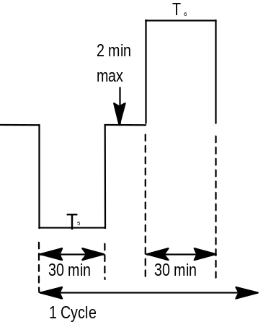
Note: To ensure test effectiveness, component covers and /or enclosures not contributing to the thermal stress mechanisms of interest should be removed so that maximum air flow around stress-fatigue points is achieved and a ramp rate of 10 to 20 degrees C per minute is achieved.

5.7.1 Equipment and Facilities.
The chamber(s) shall be capable of maintaining the specified temperature(s) in the working space within the tolerances given in sections 2.1.4 and 3.0. Forced air circulation may be used to maintain homogeneous conditions.
5.7.2 Test Setup and Preparation.
NOTE: Before start of test, submit a copy of the Reflow, Wave, and / or Selective Solder Machine temperature profile with written verification that the profile meets the solder and component manufacturer's thermal requirements to the Ford D&R engineer.
a. Before the start of test inspect all 8 samples and section 2 of them. The solder quality must meet IPC Quality Level 3 and there must be no voids, holes or cracks greater than Class 3, see figure 4 below, in the solder. An 8 D will be started to determine the root cause of the voids/holes and fixes proposed. Provide pictures of all sections and a representative number of each joint type.
b. The 6 remaining samples shall be visually inspected for cracks and holes at 250, 500, 750 and 1000 cycles and must pass the Performance Evaluation test at the end of the 1000 cycles. Three of the samples shall be sectioned and compared to those at 0 cycles. If cracks are found to be propagating into the joint from the voids/holes the other three samples must run the Group V test and pass the Performance Evaluation test at the end. Any non compliance in any of the Monitored or Performance Evaluation tests will be considered a failure and will require the process be adjusted and the test procedure listed above repeated until the parts pass.
If there are no holes, voids or cracks greater than Class 3 the test is considered a pass.
Run the remaining 3 samples for an additional 1000 cycles or to failure for information only, inspecting every 250 cycles. Provide pictures as required above at point of failure or at 2000 cycles.
c. Mount the DUT’s in the chamber, orientation should simulate that used in the vehicle, if practical. It is highly recommended that the DUTs be rack mounted, not just left on the floor of the chamber.
Thermal couple two of the test samples and run a few pretest cycles to verify that the substrate temperature reaches set point and that the rate of change between temperatures is 10 to 20 degrees C before the start of the test. Put copies of the recorded temperature profiles in the test log.
5.7.3 Operation.
TWO CHAMBER -
a. Bring both chambers to their respective set temperatures T5 and T6 as indicated in figure 3 above and start the first cold soak cycle.
b. When the DUT’s have soaked for 30 minutes remove them from the cold chamber and install them in the hot chamber. This must be done in two minutes or less.

Note: The board substrate temperature rate of change must meet or exceed 10 degrees C but not exceed 20 degrees C per minute.
c. Soak the DUT’s for 30 minutes, remove them and install in the cold chamber within 2 minutes, soak for 30 minutes remove them from the cold chamber and install them in the hot chamber.
Continue to cycle the DUT’s for 1000 cycles, perform a Visual Inspection of the joints and coatings once every 250 cycles.
When the test is complete return DUT’s to room ambient and perform the required Performance and Visual evaluations as specified in section 1.3 above.
d. Additional acceptance requirement: no cracks greater than level 3 as shown in figure 4 below in the solder, no tin whiskers or no cracks or bubbles in coatings allowed.
ONE CHAMBER -
a. Bring the chamber to temperature T5 for the DUT’s first cold soak cycle as indicated in figure 3 and start the first cold soak cycle.When the DUT’s have soaked for 30 minutes start the hot cycle at the T6 temperature for 30 minutes.
Note: The board substrate temperature rate of change must meet or exceed 10 degrees C but not exceed 20 degrees C per minute.
Continue to cycle the DUT’s for 1000 cycles, perform a Visual Inspection of the joints and coatings once every 250 cycles.
When the test is complete perform the required Performance and Visual evaluations in section 1.3 above.
b. Additional acceptance requirement: no cracks greater than level 3 as shown in figure 4 below in the solder, no tin whiskers and no cracks or bubbles in coatings allowed.

Figure 4
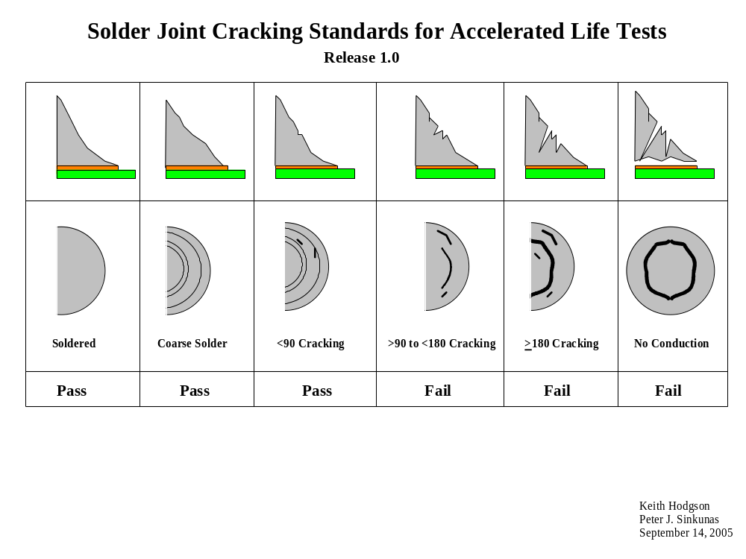
5.8 HUMIDITY-TEMPERATURE CYCLE/ NON CONDENSING. 6.4.5.8.1

- Ford CETP 00.00-E-412
- JASO D001 6.17
- IEC 68-2-38
- MES PA 67600 6.10.6
Figure 5

Operate the component continuously at normal load stress conditions during the operating portion of the cycle.
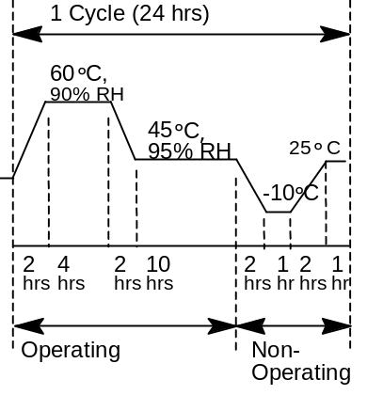

5.8.1 Equipment and Facilities.
- The chamber shall be capable of maintaining the specified temperature and humidity in the working space within the tolerances given in sections 2.1.4 and 3.0. Forced air circulation may be used to maintain homogeneous conditions.
- It shall also meet the following requirements: All parts of the test chamber and the supporting racks that come into contact with the DUT’s shall be constructed of material or will be buffered with material that will not cause electrolytic corrosion. Condensation will not be allowed to drip on or form on DUT’s.
- Any equipment required to properly monitor and verify that the DUT’s are functioning properly.

5.8.2 Test Setup and Preparation.
a. Mount the DUT’s in the chamber, orientation should simulate that used in the vehicle if possible. Connect the monitoring instrumentation and verify that the DUT’s are functioning properly.
NOTE: All water used during the test shall be fresh water with resistance of not less than 50k ohms/cm.
Heating and cooling rate: Not to exceed 1 °C/minute.
Humidity: SET POINT ± 5 % NON-CONDENSING.
5.8.3 Operation.
a. Power up chamber and run the profile as indicated in the figure 5 abovein and expose the DUT’s for 5 cycles while monitoring the DUT’s as specified in section 1.3 above.
b. When the test is complete return the temperature to TN and perform the required Functional and Visual evaluations as specified in section 1.3 above. If the DUTs pass proceed to the next test.
5.8 HUMIDITY-TEMPERATURE CYCLE/ CONDENSING. 6.4.5.8.2

- Ford CETP 00.00-E-412
- JASO D001 6.17
- IEC 68-2-38
- MES PA 67600 6.10.6
Figure 5

Operate the component continuously at normal load stress conditions during the operating portion of the cycle.
60°C

90% RH
45°C

,
95% RH
-
10°C
25°C

Operating
Non
-
Operating
12M

4H
5M
10H
19M
7M
1H

2H

1 Cycle (24 hrs)

NOTE: M = MIN
H = HOUR
NOTE: All temperature transitions shall change at 3 degrees C per minute.
5.8.1 Equipment and Facilities.
- The chamber shall be capable of maintaining the specified temperature and humidity in the working space within the tolerances given in sections 2.1.4 and 3.0. Forced air circulation may be used to maintain homogeneous conditions.
- It shall also meet the following requirements: All parts of the test chamber and the supporting racks that come into contact with the DUT’s shall be constructed of material or will be buffered with material that will not cause electrolytic corrosion. Any equipment required to properly monitor and verify that the DUT’s are functioning properly.

5.8.2 Test Setup and Preparation.
a. Mount the DUT’s in the chamber, orientation should simulate that used in the vehicle if possible. Connect the monitoring instrumentation and verify that the DUT’s are functioning properly.
NOTE: All water used during the test shall be fresh water with resistance of not less than 50k ohms/cm.
Humidity: SET POINT ± 5 %
5.8.3 Operation.
a. Power up chamber and run the profile as indicated in the figure 5 above in and expose the DUT’s for 3 cycles while monitoring the DUT’s as specified in section 1.3 above.
b. When the test is complete return the temperature to TN and perform the required Functional and Visual evaluations as specified in section 1.3 above. If the DUTs pass proceed to the next test.
5.9 WATER/FLUIDS INGRESS. 6.4.5.9
5.9.1 Immersion.6.4.5.9.1

- Ford CETP 00.00-E-412
- JIS 0203
- (JASO D001 6.21)
- IEC 68-2-17
- MIL-STD 810E 512.3
5.9.1.1 Equipment and Facilities.
- The chamber shall be capable of maintaining the specified temperature in the working space within the tolerances given in sections 2.1.4 and 3.0. Forced air circulation may be used to maintain homogeneous conditions.
- An immersion bath of sufficient depth to submerge the DUT’s.
- Any equipment required to max load the DUT’s.
- A tracer, i.e. florescent, to add to the water to simplify its detection
5.9.1.2 Test Setup and Preparation.
a. Mount the DUT’s in the chamber.
b. Measure and record the water temperature in the test log.
5.9.1.3 Operation.
a. Heat DUT’s to T6 as specified in Table 6.7 and operate at max load until the DUT’s internal temperature stabilizes.
b. Immerse DUT’s within two minutes in water with a temperature of 18 °C to a depth of 0.15 meter for 30 minutes.
c. When the test is complete perform the required Functional, Visual, and Internal Inspection evaluations.
d. Additional pass criteria is no water is allowed inside of part.
e. If the DUTs pass continue on to the next test.

5.9.2 Car Wash Spray. 6.4.5.9.2
- Ford CETP 00.00-E-412
- IEC Pub. 529 Section 14.2

5.9.2.1 Equipment and Facilities.
- The chamber shall be capable of maintaining the specified temperature in the working space within the tolerances given in sections 2.1.4 and 3.0. Forced air circulation may be used to maintain homogeneous conditions.
- One or Two Car Wash spray wand nozzles which meet the requirements of section 5.9.2.3.b
- Any equipment required to max load the DUT’s.
5.9.2.2 Test Setup and Preparation.
a. Mount the DUT’s in the chamber.
5.9.2.3 Operation.
a. Heat DUT’s to T6 as specified in Table 6.7 and operate at max load until the DUT’s internal temperature stabilizes.
b. Within two minutes subject the DUT’s to the high pressure spray of 85kgf /cm² (1220 psi) high pressure spray using 1 or 2 nozzles at a 90° angle with a 1000 L /hr. flow rate for 2 minutes. Orient the component such that the most severe spray angles are obtained.
Orientate the component such that the most severe spray angles are obtained in relation to the vehicle mounting position.

NOTE: The DUT’s may be operational or non operational as the D&R engineer indicates.
c. When the test is complete perform the required Functional, Visual, and Internal Inspection evaluations as specified in section 1.3 above.
d. Additional pass criteria is no water is allowed inside of part. If the DUTs pass continue on to the next test.

5.9.3 Heavy Splash/Shower.6.4.5.9.3
- Ford CETP 00.00-E-412
- JIS 0203 1976 (JASO D001 6.21)
- IEC Pub. 529 Section 14.2

5.9.3.1 Equipment and Facilities.
- The chamber shall be capable of maintaining the specified temperature in the working space within the tolerances given in sections 2.1.4 and 3.0. Forced air circulation may be used to maintain homogeneous conditions.
- Spray chamber that meets or exceeds the requirements of SAE J575 DEC88 or JIS 0203, 1976.
- Any equipment required to max load the DUT’s.
5.9.3.2 Test Setup and Preparation.
a. Mount the DUT’s in the chamber.
      - Operation.
a. Heat DUT’s to temperature T6 (as specified in Table 6.7) and operate at max load until the DUT’s internal temperature stabilizes.
b. Within two minutes subject the DUT’s to heavy water shower using forty 1.2 mm diameter nozzles with 3kgf /cm² pressure and 39.2 L /min. flow for 1 hour. Orient the DUT’s such that the most severe spray angles are obtained.
NOTE: The DUT’s may be operational or non operational as the D&R engineer indicates.
When the test is complete perform the required Functional, Visual, and Internal Inspection evaluations.
- Additional pass criteria is no water is allowed inside of part.
If the DUTs pass continue on to the next test.

5.9.4 Light Spray/Rain. 6.4.5.9.4
- Ford CETP 00.00-E-412
- JIS 0203 1976
(JASO D001 6.21)
- IEC Pub. 529 Section 14.2

5.9.4.1 Equipment and Facilities.
- The chamber shall be capable of maintaining the specified temperature in the working space within the tolerances given in sections 2.1.4 and 3.0. Forced air circulation may be used to maintain homogeneous conditions.
- Spray chamber that meets or exceeds the requirements of SAE J575 DEC88 or JIS 0203, 1976.
- Any equipment required to max load the DUT’s.
5.9.4.2 Test Setup and Preparation.
a. Heat DUT’s to temperature T6 (as specified in Table 6.7) and operate at max load until the DUT’s internal temperature stabilizes.
5.9.4.3 Operation.
a. Within two minutes subject the component to light water shower using two 0.5 mm diameter nozzles with 3kgf /cm² pressure and 3.2 L /min. flow for 10 minutes. Orient the component appropriately according to worst case vehicle conditions. the DUT’s to the water spray as specified in Table 6.8. Orient the DUT’s such that the most severe spray angles are obtained.
NOTE: The DUT’s may be operational or non operational as the D&R engineer indicates.
When the test is complete perform the required Functional, Visual, and Internal Inspection evaluations.
b. Additional pass criteria is no water is allowed inside of part.
c. If the DUTs pass continue on to the next test.

5.9.5 Drip. 6.4.5.9.5
- Ford CETP 00.00-E-412
- IEC Pub. 529 Section 14.2

5.9.5.1 Equipment and Facilities.
Fixtures that allow the drip rate to be controlled as specified below. .
A tracer, i.e. florescent, to add to the water to simplify its detection.
5.9.5.2 Test Setup and Preparation.
a. Mount the DUT’s in the holding fixture.
5.9.5.3 Operation.
a. Subject the DUT’s to 2 drops of water per second for 1 hour. Orient the DUT’s 20 cm below the water drop nozzle according to the worst case vehicle conditions. Additional tests may be required if there are more than one worst case condition.
b. When the test is complete perform the required Functional, Visual, and Internal Inspection evaluations.
c. Additional pass criteria is no water is allowed inside of part. If the DUTs pass continue on to the next test.
5.10.1 DUST. 6.4.5.10.1 Static test
- JIS D0207
(JASO D001 6.23)
- IEC 529 Section 13.4, 13.5
- MES PA 67600 6.13.4
- SAE J1211

5.10.1.1 Equipment And Facilities.
Dust chamber charged with 3 to 5 kg of test dust and capable of agitating the dust by means of compressed air or fan blower(s) so as to diffuse the dust throughout the chamber. The chamber must be large enough so that there is a minimum space of 100 mm between all surfaces of multiple DUT’s and the chamber itself.
5.10.1.2 Test Setup And Preparation.
a. Mount the DUT’s in the test chamber.
5.10.1.3 Operation.
a. Subject the DUT’s to dust aggitation specified in Table 6.8 for 8 hours. When the test is complete carefully wipe or shake off excess dust and perform the required Functional and Visual evaluations as specified in section 1.3 above and if the DUTS pass continue on to the next test.
For China dust tests pull DUTs every 2 hours and perform the required Functional and Visual evaluations as specified in section 1.3 above and if the DUTS pass continue on to the next test.
NOTE: For testing in the Americas it is recommended that the “dust” used be equivalent 140 Mesh silica flow, available from the US Silica Co. Ohawa, IL.
For testing outside the Americas it is recommended that the dust specified in either the JIS D0207 or IEC 529 section 13.4.5 be used.
For China it is recommended that the dust specified meet the Ford FLTM_BZ_106-01. http://www.mats.ford.com/mats/data/fltm/bz106-01.pdf
NOTE: Any non compliance up to or at the 2 hour inspection is considered a failure. Any failure after the 2 hour inspection will be 8Dd and the proposed fix reviewed with the Ford D&R Engineer for direction.

5.10.2 Dust: Dynamic.6.4.5.10.2
Reference:
MIL=-STD 810F, Method 510.4 blowing dust procedure.
5.10.2.1 Equipment And Facilities.
Dust chamber charged capable meeting the concentration and flow requirements stated below. The chamber must be large enough so that there is a minimum space of 100 mm between all surfaces of multiple DUT’s and the chamber itself.
5.10.2.2 Test Setup And Preparation.
a. Mount the DUT’s in the test chamber.
b. The test shall be performed on the complete assembled system. If the display is separate attach the display to the bezel/chassis assembly with a metal bracket.
c. Orientation of the Device Under Test (DUT): The orientation of the DUT will be in such a way as to have the face plate normal to the direction of the dust velocity and facing it
d. This test shall be done with DUT powered.
5.10.2.3 Operation.
a. Subject the DUT’s to dust concentration and at the velocity listed below for 3 hours.
Stop the test once per hour, wipe or shake off excess dust and perform the required Functional and Visual evaluations as specified in section 1.3 above.
b. Temperature of the test chamber: 25-35 °C
c. Dust Concentration: 0.1 to 0.3 gm/cu. m
d. Dust Velocity: 2.5 m/s +/- 0.5 m/s
NOTE: Any non compliance up to or at the 1 hour inspection is considered a failure. Any failure after the 1 hour inspection will be 8Dd and the proposed fix reviewed with the Ford D&R Engineer for direction.
NOTE: For testing in the Americas it is recommended that the “dust” used be equivalent 140 Mesh silica flow, available from the US Silica Co. (http://www.u-s-silica.com/) or any equivalent.
For testing outside the Americas it is recommended that the dust specified in either the JIS D0207 or IEC 529 section 13.4.5 be used.
For China it is recommended that the dust specified meet the Ford FLTM_BZ_106-01. http://www.mats.ford.com/mats/data/fltm/bz106-01.pdf

If the DUTs pass continue on to the next test.

5.11 VIBRATION-SINE. 6.4.6.1. (KEY LIFE TEST)
- Ford CETP 00.00-E-412
- JIS D1601-90
(JASO D001 6.19)
- IEC 68-2-6

NOTE: FOR PV TESTING IF THE CASE TOOL HAS MULTIPLY CAVITIES A REPRESENTATIVE NUMBER OF PARTS MUST BE TESTED FROM EACH ONE. TWO OR THREE FROM EACH WOULD BE A RECOMMENDATION, NO LESS THAN ONE EACH IS ACCEPTABLE. IF ADDITIONAL PARTS NEED TO BE ADDED AT THIS TEST STEP IT IS ACCEPTABLE TO DO SO WITHOUT PRE CONDITIONING.

Powered Vibration Endurance,

Table 6.4.6.a Vibration Classifications
Vehicle Location | Vehicle Mounting Classifications  for components and/or component /  bracket assemblies)
 | No. | Description*
Mounted to Body Structure (away from suspension attachment points) | I | Mild
Mounted to Non–Rigid or Cantilevered Body Attachments, Panels, etc., (bumpers, radiator support, etc.) | II | Moderate
Mounted to Body near suspension attachment points | III | Severe
On Suspension (on wheel and below springs) | IV | Very Severe
On Engine | V | Extremely Severe
Unique and Special Case Locations | VI | Non–Standard Case or  Vehicle specific data available
*Refer to Table 6.4.6b below for exact testing parameters.

5.11.1.1 Equipment and Facilities.
- Vibration-inducing machine and any necessary holding fixtures. The machine must be capable of maintaining the “g” force and frequency within the requirements specified in section 3.1.
Any test fixture must have “flat” response through test frequency range. If test range is above 1 K Hz a control system may be used to attenuate.
- Any equipment required to properly monitor and verify that the DUT’s are functioning properly.
5.11.1.2 Test Setup and Preparation.
a. Install the DUT’s on the vibration Table.
b. Connect the monitoring instrumentation and verify that the DUT’s are functioning properly.
c. Measure the resonance of each DUT in the X, Y and Z axis and add print out to the test log and include in the test report.
5.11.1.3 Operation.
a. Expose the DUT’s as specified in Table 6.4.6.b
b. When the test is complete perform the required Functional and Visual evaluations as specified in section 1.3 above and if the DUTs pass continue on to the next test.
c. The goal for the resonant frequency in each axis is:
Good: above 100 hz
Better: above 200 hz
Best: above 300 hz

Table 6.4.6.b
Classification |  | Vibration Method | Acceleration  (m/s²)  See note #3 | Frequency  (Hz) | Sweep Type | Time Per Sweep  (Minutes) | Number of Sweeps Per Axis | Number of Axes | Total
Number | Description |  |  |  |  |  |  |  | Sweeps  See  Note 4 | Duration
I | Mild  On Body  Away From Suspension Attachment Points | A | 10mm–p–p Displacement limited  44.1(4.5g’s)  19.6(2g’s)  4.9(0.5g’s) | 5 – 15  15 – 25  25 – 100  100 – 200 | Log | 20 | 18 | 3 | 54 | 18.0 (hrs)
II | Moderate  On Non–Rigid or Cantilevered Body Attachments, Panels, etc. | A | 10mm–p–p Displacement limited  58.9(6g’s)  29.4(3g’s)  19.6 (2g’s) | 5 – 17.3  17.3 – 50  50 – 100  100 – 200 | Log | 20 | 18 | 3 | 54 | 18.0 (hrs)
III | Severe  On Body  Near Suspension Mounting Points | A | 10mm–p–p Displacement limited  68.6(7g’s)  44.1(4.5g’s)  29.4(3g’s) | 5 – 18.6  18.6 – 50  50 – 100  100 – 200 | Log | 20 | 18 | 3 | 54 | 18.0 (hrs)
IV | Very Severe  On Wheel/ Suspension (below springs) | A | 10mm–p–p Displacement limited  196.0(20g’s)  44.1(4.5g’s)  29.4(3g’s) | 5 – 31.4  31.4 – 50  50 – 100  100 – 200 | Log | 20 | 18 | 3 | 54 | 18.0 (hrs)
V | Extremely Severe  On Engine | A | 10mm–p–p Displacement  limited  68.6m/s2 (7g’s)  5mm Displacement limited  235.2m/s2 (24gs)  294m/s2 (30g’s)  215.6m/s2 (22g’s) | 5 – 18.6 hz  18.6 – 26.4 hz  26.4 – 48.8 hz  48.8 – 200 hz  200 – 1000 hz  1000 – 2000 hz | Log | 32.4 | 32 | 3 | 96 | 51.8 (hrs)
VI | Vehicle  Specific  Case/  As Agreed by supplier and user. | A | Use when vehicle specific data is available or components are mounted in unique locations not falling into classifications I - V (e.g., on in/line tubing, hoses, wiring harnesses, motors, etc.) may require a non–standard test. Such a test must be determined based on vehicle vibration data.
NOTE 1: The test method for Classification V - On Engine is based on 4–cylinder engine data.
NOTE 2: All test methods are based on passenger car/light truck Ford vehicle durability routes corresponding to 150,000 mile customer usage.
NOTE 3: For components where the vehicle position is known and controllable the x and y axis g forces can be reduced 70% from those stated in the table.
NOTE 4: Number of sweeps may be adjusted upward to validate to a higher mileage. Current sweep counts replicate 150k miles of damage. For example for 250k miles the 54 swepes would become 90.

  - AUDIBLE NOISE 6.4.6.2.
5.12.1 Audible Noise Vibration
5.12.1.1 Equipment and Facilities.
Vibration-inducing machine and any necessary holding fixtures. The machine must be capable of maintaining the “g” force and frequency within the requirements specified in section 3.1.
Any test fixture must have “flat” response through test frequency range. If test range is above 1 K Hz a control system may be used to attenuate.
5.12.1.2 Test Setup and Preparation.
a. Install the DUT’s on the vibration Table.
5.12.1.3 Operation.
a. Expose the DUT’s for one logarithmic sweep and monitor the DUT’s for buzzes, squeaks and rattles throughout the full frequency range, see table 6.4.6.c below for frequencies and levels. Pass criteria is no noise emitted during the test.
b. Remove the DUT’s and shake and twist/shake by hand while checking for buzzes, squeaks and rattles. Pass criteria is no noise emitted during the evaluation.
c. When the test is complete perform the required Functional and Visual evaluations as specified in section 1.3 above and if the DUTs pass continue on to the next test.
Table 6.4.6.c
Vibration  Method | Frequency  (Hz) | Acceleration (m/s²)  See note #2 | Sweep  Type | Time  Per Sweep  (Minutes) | Number  Axes | Number of  Sweeps  Per Axis | Total
 |  |  |  |  |  |  | Sweeps | Duration (h)
A | 5 – 10  10 – 25  25 – 100  100 – 200 | Displacement limited less than  10mm–p–p  19.6(2g’s)  9.8(1g)  4.9(0.5g) | Log | 20 | 3 | 1 | 3 | 1
NOTE 1: This test is specifically designed for components located in the passenger and luggage compartment, however, it may be applied to components in other locations as agreed by supplier and user. Test methods for components in Vibration Classifications II-VI may also be determined by supplier and user (1 sweep in each axis at 1/2 the acceleration levels given in Table 4.6.1 is recommended) if desired.
Note 2: For components where the vehicle position is known and controllable the x and y axis g forces can be reduced 70% from those stated in the table.

  - MECHANICAL SHOCK/DROP 6.4.6.3.

Classifications |  | Examples of Types of Components | 6.4.6.3 Mechanical Shock / Drop Test Requirement*  See Note 3 |  |  |  | Required  Labeling  for  Component | Processing/  Handling  Approach
No. | Description |  | 6.4.6.3.1  Package  Drop | 6.4.6.3.2  Handling  Drop | 6.4.6.3.3  Medium  Mechanical  Shock | 6.4.6.3.4  Low Mechanical  Shock
I | Non–robust Component Design /  Careful Handling &  Protective Packaging | Instrument clusters,  displays, etc. | X  (See  Note 1) |  |  | X | “Set aside  if  Dropped” | Minimize rough  handling. Control damaged material.
II | Semi–robust Component Design/  Large  Mass | Electronic modules,  large mass etc. |  |  | X |  | “Set aside  if  Dropped" | Minimize rough handling. Control damaged material.
III | Robust Component  Design /  Minimal Handling  Precautions | Encased sensors, small modules, etc. |  | X |  |  | N/A | No special controls.
Note 1: 4.6.3.1 Package Drop is required only for packages designed for human handling (18kg max).
Note 2: 4.6.3.1&.2 require 14 test samples, 1 drop per sample, 6 sides and 8 corners.
Note 3: The High Repetition Mechanical Shock.(BUMP TEST) 6.4.6.3.5 shall be used as defined by the Ford D&R engineer.
* For each classification perform the tests identified with an “X”.

    - Package Drop. 6.4.6.3.1
NOTE: Package Drop is required only for packages designed for human handling (18kg max).
NOTE: It is required that the Ford D&R engineer contact the Dunnage Engineer at the Ford VO plant where this DUT is to be used to determine if there are any plant specific Package Drop/Validation tests. If there are those tests will be run in place of these. If none exist this test or one that's deemed equivalent shall be run during the PV validation.

- JIS C0912
(JASO D001 6.20)
- IEC 68-2-32
- MES PA 67600 XXX
- MIL-STD-810E 516.4 Procedure IV

5.13.1.1 Equipment and Facilities.
- DUT’s in its protective shipping package and a concrete or steel surface and stanchion to control drop height and orientation.
- Ring stand or equivalent.
- Quick disconnect hook.
5.13.1.2 Test Setup and Preparation.
a. Install the DUT’s and its protective shipping package in the holding fixture.
5.13.1.3 Operation.
a. Drop the package a distance of 100 cm onto a concrete or steel surface. Repeat once for each package surface and corner.
NOTE: The component specification will define whether one or more packages are to be used for this test. It is suggested that 14 packages be used, one drop per package.
b. When the test is complete open the package and perform the required Functional and Visual evaluations as specified in section 1.3 above.
    - Handling Drop. 6.4.6.3.2
- JIS C0912
- (JASO D001 6.20)
- IEC 68-2-32
- MIL-STD-810E 516.4 Procedure IV

5.13.2.1 Equipment and Facilities.
- DUT’s and a concrete or steel surface and stanchion to control drop height and orientation.
- Ring stand or equivalent
- Quick disconnect hook
5.13.2.2 Test Setup and Preparation.
a. Concrete or steel surface. The drop height is 76 cm.
5.13.2.3 Operation.
a. Drop once on each face and once on each corner, one DUT per drop.
NOTE: 14 samples are required for this test.
b. When the test is complete perform the required Functional and Visual evaluations as specified in section 1.3 above and if DUTs pass continue on to the next test.
5.13.3 Medium Mechanical Shock. 6.4.6.3.3
- JIS C0912
(JASO D001 6.20)
- IEC 68-2-32, 68-2-27
- MIL-STD-810E 516.4 Procedure I and VI

5.13.3.1 Mechanical Shock Method.
EQUIPMENT AND FACILITIES.
Shock machine and any necessary holding fixtures must be capable of producing a half sine shock impulse of 100 g’s and 10 millisecond duration.
TEST SETUP AND PREPARATION.
a. Install the DUT’s on the Shock Machine. It is highly recommended that the vehicle mounting bracket/tabs NOT be used to secure the DUT.
OPERATION.
a. Expose the DUT’s to shocks of 100 gs, six repicates in each opposite direction of each perpendicular axis.
b. When the test is complete perform the required Functional and Visual evaluations as specified in section 1.3 above and if the DUTs pass continue on to the next test...
5.13.4 Low Mechanical Shock. 6.4.6.3.4
- JIS C0912
(JASO D001 6.20)
- IEC 68-2-27, 68-2-32
- MIL-STD-810E 516.4 Procedure I and VI

5.13.4.1 Mechanical Shock Method.
EQUIPMENT AND FACILITIES.
Shock machine and necessary holding fixtures must be capable of producing a half sine shock impulse of 50 g’s and 10 millisecond duration.
TEST SETUP AND PREPARATION.
a. Install the DUT’s on the Shock Machine. It is highly recommended that the vehicle mounting bracket/tabs not be used to secure the DUT.
OPERATION:
b. Expose the DUT’s to 50 gs, six replicates in each opposite direction of each perpendicular axis.
c. When the test is complete perform the required Functional and Visual evaluations as specified in section 1.3 above and if the DUTs pass continue on to the next test...
5.13.5 High Repetition Mechanical Shock.(BUMP TEST) 6.4.6.3.5
- JIS C0912
(JASO D001 6.20)
- IEC 68-2-27, 68-2-32
MIL-STD-810E 516.4 Procedure I and VI

5.13.5.1 Mechanical Shock Method.
EQUIPMENT AND FACILITIES.

Shock machine and necessary holding fixtures must be capable of producing a half sine shock impulse as defined from vehicle measurments for the specific module location on the vehicle.
TEST SETUP AND PREPARATION.
a. Install the DUT’s on the Shock Machine. It is highly recommended that the vehicle mounting bracket/tabs not be used to secure the DUT.
OPERATION:
b. Expose the DUT’s to Shock Pulse defined above for the number of replications called for by the Ford D&R engineerch in each opposite direction of each perpendicular axis.
c. When the test is complete perform the required Functional and Visual evaluations as specified in section 1.3 above and if the DUTs pass continue on to the next test...
5.14 CONNECTOR LEAD/LOCK STRENGTH. 6.4.6.4
NOTE: The intent of this test is to verify the module side of the connector system.
5.14.1 Connector Push Test.
5.14.1.1 Equipment and Facilities.
- Production Connectors and the module/component they attach to.
- Holding fixtures and force gauge.
- Rated engagement force of the connector. Default is 16kg (157N).
5.14.1.2 Test Setup and Preparation.
a. Install the DUT and harness assembly in holding fixture.
5.14.1.3 Operation.
a. Apply 1.5 times the rated engagement force to the connector in the direction of mating for one minute.
b. When the test is complete perform the required Functional and Visual evaluations as specified in section 1.3 above and if the DUTs pass continue on to the next test....
5.14.2 Connector Torque Test.
5.14.2.1 Equipment And Facilities.
- Production Connectors and the module/component they attach to.
- Holding fixtures and force gauge.
5.14.2.2 Test Setup and Preparation.
a. Install the DUT and harness assembly in holding fixture.
5.14.2.3 Operation.
a. Independently apply 4 g (39.2 m/s² ) to all four sides of the harness connector(s), perpendicular to the direction of mating, at the greatest moment arm of each axis, for one minute.
b. When the test is complete perform the required Functional and Visual evaluations as specified in section 1.3 above and if the DUTs pass continue on to the next test....
5.14.3 Connector Durability Test.
5.14.3.1 Equipment and Facilities.
- Fully populated mating connectors with terminals (one connector per component).
- Production representative torque tools set to the maximum specified fastener torque.
5.14.3.2 Test Setup and Preparation.
a. Install the DUT and harness assembly in holding fixture.
5.14.3.3 Operation.
a. Plug and unplug each connection system 11 times by hand or use the maximum specified torque if a bolt is required. the time to mate each connection system by hand must not exceed four seconds.
b. When the test is complete perform the required Functional and Visual evaluations as specified in section 1.3 above and if the DUTs pass continue on to the next test....
5.14.4 Lead/Lock Pull Test.
5.14.4.1 Equipment and Facilities.
- Production Connectors and the module/component they attach to.
- Holding fixtures and force gauge.
- Size of each wire in connector.
5.14.4.2 Test Setup and Preparation.
a. Attach the harness connectors to the DUTand install in a in holding fixture.
5.14.4.3 Operation.
a. If DUT has individual wire(s) pull each as follows:
0.3 sq. mm. dia. lead: 5 kg.(49N)
0.5 sq. mm. dia. lead: 8 kg.(78.5N)

b. If DUT has a wire bundle pull the wire bundle: 10 kg (98.1N)
c. When the test is complete perform the required Functional and Visual evaluations as specified in section 1.3 above and if the DUTs pass continue on to the next test.
5.15 SALT MIST ATMOSPHERE. 6.4.7.1
- JIS C0023
(JASO D001 6.22)
- IEC 68-2-11
- MIL-STD-810E 509.3
- MES PA 67600 6.13.3

5.15.1 Equipment and Facilities.
5.15.1.1 A test chamber with.
Supporting racks designed and constructed so that they will not affect the characteristics of the salt fog mist. All parts of the test chamber and the supporting racks that come into contact with the DUT’s shall be constructed of material or will be buffered with material that will not cause electrolytic corrosion. Condensation is not allowed to drip on the DUT’s. No liquid that comes in contact with the DUT’s or the test chamber shall return to the salt solution reservoir. The exposure chamber shall be properly vented to prevent pressure build up.
The capability to maintain temperatures in the exposure zone at 35 ± 2 °C. The use of immersion heaters within the chamber exposure area for the purpose of maintaining the temperature within the exposure zone is prohibited.
5.15.1.2 A salt solution reservoir made of material that is nonreactive with the salt solution, i.e., glass, hard rubber, or plastic.
5.15.1.3 Means for injecting the salt solution into the test chamber. Atomizers used shall be of such design and construction as to produce a finely divided, wet, dense fog. Atomization of approximately 2.8 liters of salt solution per .28 cubic meter (10 cubic feet) of chamber volume per 24 hours.
5.15.1.4 Salt fog collection receptacles placed so that a clean receptacle at any point in the exposure zone will collect from 0.5 to 3.0 milliliters of solution per hour for each 80 square centimeters (10 cm diameter) of horizontal collecting area in an average test of at least 16 hours. A minimum of 2 receptacles shall be used, one placed nearest to any nozzle and one farthest from all nozzles: receptacles shall be placed so that they are not shielded by the test item and will collect no drops of solution from the test item or other sources. Measured results are to be recorded in the test log.
5.15.1.5 Any equipment required to properly monitor and verify that the DUT’s are functioning properly. (If required).
5.15.2 Test Setup And Preparation.
CONTROLS:
a. The salt solution shall be heated before injection into the test section to 35 ± 5 °C.
b. All water used during the salt fog test shall be from steam or distilled, demineralized, or deionized water with resistance of not less than 50k ohms/cm.
c. Air circulation shall be essentially zero.
PREPARATION FOR TEST:
Salt Solution:
a. The salt used for this test shall be sodium chloride containing (on a dry basis) not more than 0.1 % sodium iodide and not more than 0.3 % total impurities. Diamond crystal kosher salt, or equivalent, unless otherwise specified, a 5 ± 1 percent solution shall be prepared by dissolving 5 parts by weight of salt into 95 parts by weight of water. The solution shall be adjusted to, and maintained at, a specific gravity of 1.037 to 1.022. Sodium tetraborate (borax) may be added to the salt solution as a pH stabilization agent in a ratio not to exceed 0.7 g sodium tetraborate to 75 liters of salt solution. The ph of the salt solution, as collected as fallout in the exposure chamber, shall be maintained between 6.5 and 7.2 with the solution temperature at35 ± °C. Only diluted chemically pure hydrochloric acid or chemically pure sodium hydroxide shall be used to adjust the pH. The pH measurement shall be made electrometrically or colorimetrically.
DUT’s:
b. The test samples shall have a functional and visual evaluation per section 1.3 above.
c. All surfaces shall be clean and free from oils, greases or other protective materials not part of the design.
d. Mount the DUT’s in the chamber, orientation should simulate that used in the vehicle.
e. Connect the monitoring instrumentation and verify that the DUT’s are functioning properly (if required).
5.15.3 Operation.
a. Adjust the test chamber temperature to 35 ± 2 °C. Condition the DUT’s for two hours before introducing the salt fog.
b. Expose the DUT’s to the salt atmosphere for the time specified in Table 6.9k. Continuously atomize a salt solution as specified above for the period specified and during the entire exposure period the salt fog fallout rate and pH of the fallout solution shall be measured at 24 hour intervals.

c. When the test in complete the DUT’s may be allowed to dry in the ambient atmosphere for 48 hours or they may be tested immediately to the required Functional, Visual, and Internal Inspection evaluations as specified in section 1.3.
If the DUTS pass continue on to the next test
NOTE: During the visual examination of the DUT’s pay particular attention to:
- High stress areas.
- Areas where dissimilar metals are in contact.
- Electrical and electronic DUT’s - especially those having a closely spaced, unpainted, or exposed circuitry.
- Metallic surfaces.
- Enclosed volume where condensation has occurred or may occur.
- DUT’s or surfaces provided with coating or surface treatments for corrosion protection.
- Cathodic protection systems; mechanical systems subject to malfunction if clogged or coated with salt deposits.
- Electrical and thermal insulators.
  - CHEMICAL RESISTANCE. 6.4.7.2
NOTE: If Ford approved materials are used this test may be waived.
5.16.1 Equipment and Facilities.
TEST EQUIPMENT.
Ample amounts of each fluid to coat the component and a 5 cm or 8 cm nylon bristle brush.
5.16.2 Test Setup and Preparation.
a. Determine the necessary chemicals from table 6.9.
5.16.3 Operation.
a. Power up chamber and stabilize at T6 c. Brush or spray the specified chemical solutions onto all exterior surfaces of the DUT’s.
b. Install DUT’s in the chamber.
c. Expose the DUT’s for 96 hours.
d. When the test is complete perform the required Functional, Visual, and Internal Inspection evaluations as specified in section 1.3 above. If the DUTs pass continue on to the next test.
NOTE: It is suggested that one sample per fluid be used.

  - WCCA/HIGH TEMPERATURE ENDURANCE 6.4.8.1 KEY LIFE TEST/ANALYSIS
NOTE: A WCCA (worst case circuit analysis) is required to use any of the mini validation methods and may be substituted for the High Temp Endurance test if there are no other high temperature failure modes in the D/PFMEA.

- JASO D001 6.14
- IEC 68-2-2B
- MIL-STD-810E501.3
Procedure II
- MES PA 676006.10.4

5.17.1 Equipment and Facilities.
- The chamber shall be capable of maintaining the specified temperature in the working space within the tolerances given in sections 2.1.4 and 3.0. Forced air circulation may be used to maintain homogeneous conditions.
- Any equipment required to properly monitor and verify that the DUT’s are functioning properly.
5.17.2 Test Setup and Preparation.
a. Mount the DUT’s in the chamber, orientation should simulate that used in the vehicle, if possible.
b. Connect the monitoring instrumentation and verify that the DUT’s are functioning properly.
5.17.3 Operation.
a. Power up chamber and stabilize at the specified temperature T2/T4 and expose the DUT’s for 1000 hours while monitoring the DUT’s as specified in section 1.3 above. Check the DUTs once per day to verify that they are operating properly.
b. When the test is complete return DUT’s to room ambient and perform the required Functional and Visual evaluations as specified in section 1.3 above.
5.18 CONTROLS DURABILITY. 6.4.8.2 KEY LIFE TEST
5.18.1 Equipment and Facilities.
- Holding fixtures and actuators for controls.
- Any equipment required to properly monitor and verify that the DUT’s are functioning properly.
5.18.2 Test Setup and Preparation.
a. Mount the DUT’s in the chamber, orientation should simulate that used in the vehicle, if possible. Connect the monitoring instrumentation and verify that the DUT’s are functioning properly.
5.18.3 Operation.
a. Operate the driver/passenger operated controls at TN for the number of cycles specified by the component specification.
b. When the test is complete perform the required Functional and Visual evaluations as specified in section 1.3 above.
5.19 MECHANICAL WEAR-OUT. 6.4.8.3 KEY LIFE TEST
5.19.1 Equipment and Facilities.
- Holding fixtures and actuators for controls.
- The chamber shall be capable of maintaining the specified temperature in the working space within the tolerances given in sections 2.1.4 and 3.0. Forced air circulation may be used to maintain homogeneous conditions.
- Any equipment required to properly monitor and verify that the DUT’s are functioning properly and a thermal chamber which meets the requirements of section 1.3 above.
5.19.2 Test Setup and Preparation.
a. Mount the DUT’s in the chamber, orientation should simulate that used in the vehicle.
b. Connect the monitoring instrumentation and verify that the DUT’s are functioning properly.
5.19.3 Operation.
a. Operate the driver/passenger operated controls at TN for the number of cycles specified by the component specification and at a normal load stress.
b. Operate the engine compartment and vehicle exterior controls at:
2/3 of the cycles at TN.
1/6 of the cycles at T1/T3.
1/6 of the cycles at T2/T4.
The temperatures are specified in Table 6.7 and the number of cycles are as specified by the component specification and at a normal load stress.
c. When the test is complete return DUT’s to room ambient and perform the required Functional and Visual evaluations as specified in section 1.3 above.
]5.20 85/85 High Temperature/Humidity Endurance 6.4.8.4
NOTE: Supplier shall provide evidence that all components used in their DUTs meet the 1000 hour 85% humidity, 85 degree Celcius requirement. No components may be used in a Ford product that do not meet this requirement.
Once the above requirement is confirmed this test is optional and should only be used when the failure mode of interest can not be verified by one of the other tests in this specification.
For electro-mechanical components, i.e. CD players, the test time may be adjusted based on industry pratice.
5.20.1 Equipment and Facilities.
a. The chamber shall be capable of maintaining the specified temperature and humidity levels in the working space within the tolerances given in sections 2.1.4 and 3.0. Forced air circulation may be used to maintain homogeneous conditions.
b. Supporting racks designed and constructed so that they will not affect the characteristics of the fog mist. All parts of the test chamber and the supporting racks that come into contact with the DUT’s shall be constructed of material or will be buffered with material that will not cause electrolytic corrosion. Condensation will not be allowed to drip on or form on DUT’s.
c. Any equipment required to properly monitor and verify that the DUT’s are functioning properly.
5.20.2 Test Setup and Preparation.
a. Mount the DUT’s in the chamber, orientation should simulate that used in the vehicle, if possible.
b. Connect the monitoring instrumentation and verify that the DUT’s are functioning properly.
NOTE: All water used during the test shall be fresh water with resistance of not less than 50k ohms/cm.
5.20.3 Operation.
a. Power up chamber and stabilize at 85 °C /85 % Humidity and expose the DUT’s for 1000 hours or as determined by the Ford D&R engineer.
Check the DUTs once per day to verify that they are operating properly.
b. When the test is complete return DUT’s to room ambient and perform the required Functional, Visual and Internal evaluations as specified in section 1.3 above.
5.21.0 HALT 6.4.8.5
NOTE: HALT (Highly Accelerated Life Test) testing is used to discover the operational and if time and samples allow destruct levels for temperature, vibration, thermal shock rate of change and combinations of the same. The results are for information only. Its assumed before we start that the design has been shown to be capable of meeting the standard environmental requirements in EY0128/CETP 00.00-E-412. The tests require a special test chamber to achieve the extreme limits for each.
We ask that each non compliance, either in op or destruct, be root caused and possible solutions be investigated. In the past we've found that for a few cents and sometimes for free we can eliminate the failure and increase the robustness of the design.
We also require that these tests be repeated on the PV samples to look for changes from the DV results. If its determined that the PV results are acceptable its then suggested the HALT be added as a IP test requirement, possibly once per month or at a minimum once per quarter for the first year of production and twice a year after if the results indicate the process robustness is stable.
A change in results, which usually indicates a weaking of the design as processed, is significant but not a show stopper since the in op levels should be greater than the spec by a significant margin. This usually indicates a change in the parts or the process that has resulted in a loss of robustness. Its required that the root cause be found and if feasable a fix be implemented to return the process to its previous level.
    - Equipment and Facilities.
NOTE: It is required that a HALT type chamber be used for this testing capable of temperatures from -100 to +200 C, thermal shock rates from 1 to 100 degrees C per minute and vibration excitation of 70gs multi-axle random as a minimum.
Any equipment required to properly monitor and verify that the DUT’s are functioning properly during the test.
5.20.2 Test Setup and Preparation.
a. It is preferably to test DUTs with the top removed and with two thermal couples attached to the board surface to monitor board temperature.
b. Conduct the Performance Evaluation test on DUTs before the start of test and on any surviving DUTs at the end of the testing.
5.20.3 Operation. Use three samples for the temperature and thermal shock tests.
Operational limit tests.
a. Cold test.
Install 3 DUTs in the chamber if practical, verify correct operation and attach two thermal couples to the board surface of one of the samples and use them as controls for the chamber during the test. Lower temperature to -40 degrees at 4 degrees C per minute max. Power up module and verify proper operation. Power off and lower the temp in 5 degree increments with a 5 minute dwell. After each dwell power up and verify proper operation. Continue until improper operation is found or -100 degrees C is reached.
If module goes inop, record temp and what the improper operation is.
Cycle power on and off to see if module will recover. If it recovers dwell for 5 minutes and then continue to the next step. If not power off and return to the temp where the module properly performed, dwell 5 minutes, power up and verify proper operation. If module doesn't recover, power off and continue the 5 degree C increase steps with 5 minute dwell until proper operation returns or –40 C is reached. If the module recovers note the temperature at which it recovers and perform the functional check at the voltages specified by the Ford D&R engineer.
When complete return the module to room ambient at 4 degrees C per minute.
If module doesn't recover note this in the test log and remove for root cause analysis at a later date. If not all samples failed return to the previous set point at 4 degrees C per minute and continue until all have failed or reached -100 C. Return to ambient when complete at 4 degrees C per minute and move to the Hot test. If the samples return to proper operation at -40C or lower they may be carried over to the Hot test. If not replace them with new modules and move on.
NOTE: Any loss of operation above -55 C is considered a failure that must be 8Dd and fixed if the mini validation test methods are to be used.
b. Hot test.
Install 3 DUT in the chamber if practical, verify correct operation and attach two thermal couples to the board surface of one of the samples and use them as controls for the chamber during the test. Raise temperature to +75 degrees at 4 degrees C per minute max. Power up module and verify proper operation. Power off and raise the temp in 5 degree increments with a 5 minute dwell. After each dwell power up and verify proper operation. Continue until improper operation is found or until T2/T4+_50 degrees C is reached.
If module goes inop, record temp and what the improper operation is.
Cycle power on and off to see if module will recover. If it recovers dwell for 5 minutes and then continue to the next step. If not power off and return to the temp where the module properly performed, dwell 5 minutes, power up and verify proper operation. If module doesn't recover, power off and continue the 5 degree C decrease steps with 5 minute dwell until proper operation returns or +75 C is reached. If the module recovers note the temperature at which it recovers and perform the functional check at the voltages specified by the Ford D&R engineer.

When complete return the module to room ambient at 4 degrees C per minute.
If module doesn't recover note this in the test log and return module to room temp at 4 degrees C/minute max and remove for root cause analysis at a later date. If not all samples failed return to the previous set point at 4 degrees C per minute and continue until all have failed or reached T2/T4 +50 C. Return to ambient when complete at 4 degrees C per minute and move to the Thermal Shock test. If the samples return to proper operation at +75C or higher they may be carried over to the Thermal Shock test. If not replace them with new modules and move on.
NOTE: Any loss of operation below T2+15 C is a considered a failure that must be 8Dd and fixed if the mini validation test methods are to be used.
c. Thermal Shock test.
Install the DUT in the chamber, verify correct operation and attach two thermal couples to the board surface of one of the samples and use them as controls for the chamber during the test.
Lower temperature to -40 degrees at 4 degrees C per minute max. Power up module and verify proper operation. Start the thermal shock test with a ramp rate of 15 degrees C per minute to T6 and dwell for as long as it takes the board to come to temperature and then power off the module and return to -40 C. Repeat this temp/power on &off cycle until the cycle has been repeated 5 times.
Increase the ramp rate in 5 degree C per minute increments and repeat the 5 cycles until a module goes inop or the ramp rate equals 50 degrees C per minute.
If a module goes inop, record the ramp rate what the improper operation is. Power the module off and on to see if it will recover. If yes make a note in the test log and continue to the next step until 50 degrees C per minute is reached or another inop point is reached which doesn't recover with power cycling. Note ramp rate and what the improper operation is and power off the module and return the ramp rate to the level where the module last operated properly. Power up the module after 1 cycle and verify operation level. If it fails to recover continue to lower the ramp rate until the module recovers or 10 Degrees C per minute is reached. If the module recovers note the ramp rate in the test log. Return the DUT to ambient temperature at a max of 4 degrees C per minute and perform the functional check at Vn.
If module doesn't recover note this in the test log and remove the DUT for root cause analysis at a later date. If not all samples failed return to the previous ramp rate and continue until all have failed or you've reached 50 degrees C per minute. Return to ambient when complete and move to the Vibration test

NOTE: Any loss of operation below at a ramp rate of less than 30 degrees C per minute is a considered a failure that must be 8Dd and fixed if the mini validation test methods are to be used.
d. Vibration test. Three new samples may be used for this test.
Firmly mount cased modules to table and mount a tri-axial accelerometer to the case of one of the samples and if practical mount two thermal couples to the board surface. Control the vibration level using the accelerometer mounted on the case if possible.
Power up and verify proper operation.
Start vibration, continue to monitor the module and slowly ramp up to 5 gs. Dwell there for 5 minutes. If module continues to operate properly increase the vibration in 5.0g increments with 5 minute dwells until a module fails to operate properly or 20gs is reached. After 20gs is reached reduced steps to 2.5gs each until 50 gs is reached or the module goes inop. If module goes inop, record the vibration level and what the improper operation is and cycle power on and off to see if module will recover. If it recovers continue to vibrate at this level for 5 minutes and then go to the next step. If not power down module and return to the last vibration level at which the module operated properly and power up and check for proper operation. If it doesn't recover power off and decrease vibration in 5.0g increments with 2 minutes dwells until operation returns or 5.0 gs is reached. If the module recovers note the g level at which it recovers and perform the functional check at the various voltages as defined by the Ford D&R engineer. If module doesn't recover note this in the test log and return module to room temp at 4 degrees C/minute max and remove for root cause analysis at a later date. If not all samples failed return to the previous set point at and continue until all have failed or reached 50gs. If the samples survive they should be used for the Thermal Shock/Vibration test. If not replace them with new modules and move on.
If module doesn't recover note this in the test log and remove for root cause analysis at a later date.
NOTE: Any loss of operation below 20gs is considered a failure that must be 8Dd and fixed if the mini validation test methods are to be used.
e. Thermal Shock/Vibration test.
Verify that the DUTs are securely mounted to the table. Power up and verify proper operation.
Lower temperature to -40 C at 4 degrees C per minute. Start the thermal shock cycle at the ramp rate the modules last performed properly during the Thermal Shock test. Start the vibration at the g level the module last operated properly at the same time. Turn the vibration on &off in two minute intervals and turn the power off when the temperature ramps down and back on when the temperature ramps up.
Use the thermal couples mounted to the board to verify the board is at the min or max temperature before the return ramp cycle begins.
Continue for 20 cycles or the modules perform improperly. If any module goes inop note in the test log what the improper operation is and whether the vibration was on or off, temperature state, increasing, decreasing or stable.
Power off the module and turn back on to see if it recovers, if yes continue test, if not power off and turn off the vibration if its on and return the module to room ambient at 4 degrees C per minute. Power up the module to see if it recovers, if yes note it in the test log and remove the module.
If there are modules which were still operating properly return to point of the previous failure and continue to 20 cycles or the next failure.
If the modules survive 20 cycles note this in the test log and turn off the vibration and return the modules to room ambient at 4 degrees C per minute.
All surviving modules should run through the Performance Evaluation test, 6.2.1, and the results should be compared to those taken in the pretest evaluations.
End of test
6.0 general instructions
6.1 HOW TO USE THIS DOCUMENT
    - Determine where the DUT is located in the vehicle.
- Use the various tables to determine the excitation levels for the various tests.
    - Create a table in your VDS, SDS or CDS that lists the environments as rows and the Classification levels as a column. This table with a note that you're using EESYS/EY0128 as your test standard is all you need to define all the environmental test requirements.
    - Determine test group(s) required using the flow chart in section 6.1.2 below and list these in your document.
    - With your supplier(s) define what the acceptance criterias are for the various evaluations/checks/monitored operation will be and include them in your document, i.e. those described in sections 6.2.1, .2, .3, .4, .5, .6 below. They should also be listed and detailed at the top of the D/PVP&R in detail or with a reference to the section numbers where they are described in your controling document.

    - If you have specific needs for additional samples or special tests based on your application/technology add those also with their associated acceptance criterias.
6.1.6 https://f1.ford.com/eRoom/EESE/eeseprocess/0_3199f7
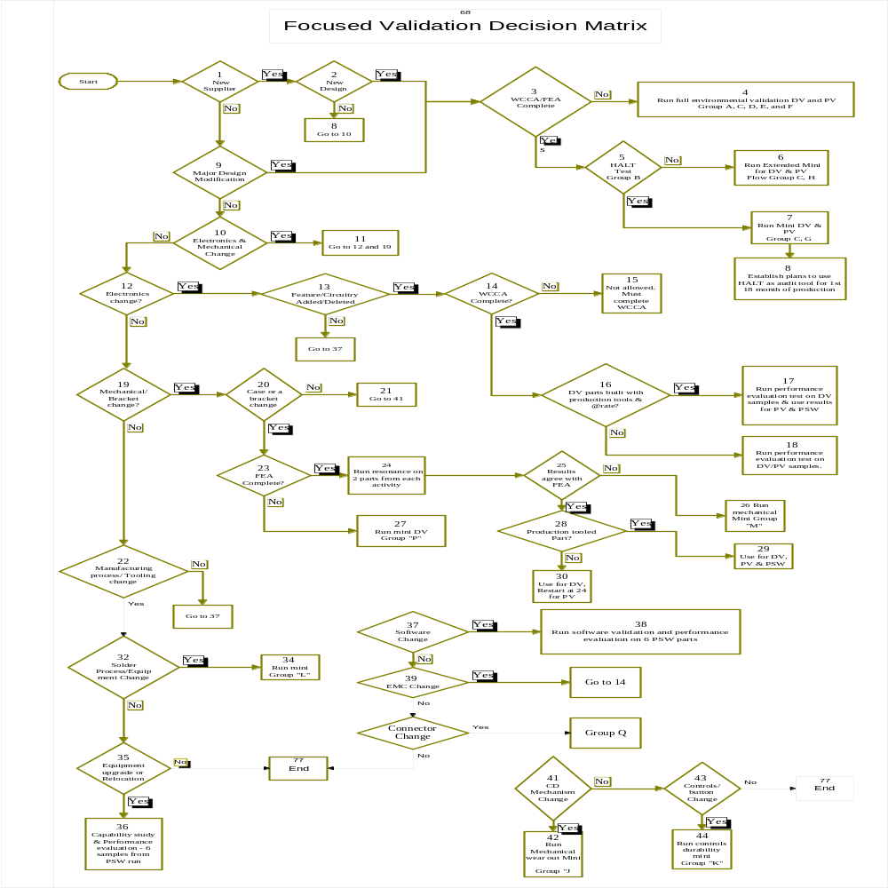
6.2 Performance, functional and inspection evaluation methods

REQUIREMENTS |  | EVALUATION |  | REFERENCE TEST PROCEDURES
Ref No. | Title | METHOD | ACCEPTANCE
4.1.1 PERFORMANCE, FUNCTION AND INSPECTION EVALUATIONS
6.2.1 | Performance  Evaluation | Measure and record component performance parameters specified in the component engineering specification at the 5 temperature–voltage points shown below.  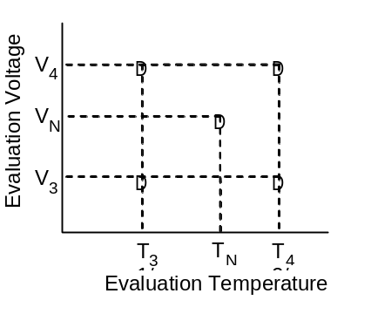  Note:  T1/3 = Low Temperature for Performance Evaluation  TN = Nominal Temperature for Performance Evaluation  T2/4 = High Temperature for Performance Evaluation  VN = Nominal Voltage  V3 = Low Voltage of Guaranteed Performance  V4 = High Voltage of Guaranteed Performance | Component shall satisfy performance requirements as specified per section 6.3 below.

REQUIREMENTS |  | EVALUATION |  | REFERENCE TEST PROCEDURES
Ref No. | Title | METHOD | ACCEPTANCE
4.1.1 PERFORMANCE, FUNCTION AND INSPECTION EVALUATIONS
6.2.2 | Functional Check | Operate the component at Function Check Test Voltage V₅ (V_{N} ±1.5V) and specified load stress conditions at either room temperature, T_{N} or test chamber set temperature. Evaluate a subset of the component function/performance characteristics specified in the component specification. Record any discrepancies or abnormal operation. Functional Checks shall be performed immediately after or within 24 hours following each environmental test as appropriate and/or as specified. | Component shall satisfy functional performance requirements as specified per section 6.3 below.
6.2.3 | Monitored Operation | Operate the component at Monitored Operation Test Voltage V₆ (V_{N}±0.5V) and specified stress conditions during the environmental test. Monitor component characteristics to verify proper operation as specified in the component engineering specification. Record any discrepancies or abnormal operation. | Component shall satisfy operation requirements as specified per section 6.3 below.

REQUIREMENTS |  | EVALUATION |  | REFERENCE TEST PROCEDURES
Ref No. | Title | METHOD | ACCEPTANCE
4.1.1 PERFORMANCE, FUNCTION AND INSPECTION EVALUATIONS
6.2.4 | Functional  Evaluation | Evaluate component functional characteristics specified in the component engineering specification at the 4 temperature voltage points shown below if different than those required in 6.3.1. Record observations.  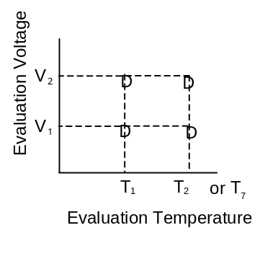  Note:  T₁ = Minimum Operating Temperature  T_{2/7} = Maximum Operating Temperature  V₁ = Low Voltage of Guaranteed Function  V₂ = High Voltage of Guaranteed Function  T₇ = High Temperature for Functional Evaluations | Component shall satisfy functional requirements as specified per section 6.3 below.

REQUIREMENTS |  | EVALUATION |  | REFERENCE TEST PROCEDURES
Ref No. | Title | METHOD | ACCEPTANCE
4.1.1 PERFORMANCE, FUNCTION AND INSPECTION EVALUATIONS
6.2.5 | Visual Check | Examine the component for visible signs of deterioration or damage. Perform dimensional measurements if necessary to determine acceptability. Visual Checks shall be performed immediately after or 24 hours following each environmental test as appropriate and/or as specified. | The component shall meet acceptance criteria as specified in the component engineering specification as specified per section 6.3 below.
6.2.6 | Internal  Inspection | Using appropriate physical and/or visual techniques, inspect printed wiring board/substrate assemblies to evaluate the condition of electrical interfaces and connections. Internal Inspections shall be performed, when required, within 24 hours following the environmental test as appropriate and/or as specified. Inspection procedures not sensitive to time elements and/or requiring scheduling of laboratory facilities may be performed at extended time periods. | The component shall meet acceptance criteria as specified in the component engineering specification as specified per section 6.3 below.

6.3 Performance, functional and inspection evaluation acceptance requirement specificationsEVALUATION  REQUIREMENT |  | PURPOSE | SPECIFICATION ITEMS  (To be considered/contained in component acceptance specification)
No. | Title
4.1.1 PERFORMANCE, FUNCTION AND INSPECTION EVALUATIONS
6.3.1 | Performance  Evaluation | To thoroughly evaluate component electrical and mechanical performance before and after environmental testing.  NOTE: these evaluations must be performed in the thermal chamber at the prescribed set temperatures.  If variables data are collected the Ford D&R engineer will pick 5 signals for degradation analysis. These data will be plotted using box plots versus design specs and included in the test report. | a. Component performance parameters with quantifiable acceptance criteria/limits (e.g., voltages, current, frequencies, input/output characteristics, display intensities, computations, KOL(key off load) and time outs etc).  b. Minimum, Maximum and Nominal Temperatures (T1/₃, T2/₄ and T_{N} respectively) for performance evaluations. Temperature selection should be in accordance with Table 6.5  c. Minimum, Maximum and Nominal test supply voltages (V₃, V₄, and V_{N} respectively) should be in accordance with Tables 6.6.
6.3.2 | Functional  Check | To reasonably verify component function and performance between subsequent environmental tests. | a. Identification of the characteristics necessary to verify satisfactory function after each environmental stress. Qualitative requirements for the characteristics should be defined.  b. Supply voltage and temperature (V₅ and T_{N or chmber} set temperature) per Tables 6.6.
6.3.3 | Monitored  Operation | To verify that the component operates properly in the environment in which it is being evaluated. | a. Functional or performance characteristics with quantifiable criteria/limits necessary to determine satisfactory operation during exposure to the environments.  Note: Characteristics should be determined based on subsystem operational requirements, functional importance class, FMEA’s, applicable regulatory/safety requirements, company standards and the “Typical Environmental Effects” listed in Table 6.4.5 as applicable.  b. Supply voltage, V₆ as specified in Tables 6.6.

EVALUATION  REQUIREMENT |  | PURPOSE | SPECIFICATION ITEMS  (To be considered/contained in component acceptance specification)
No. | Title
4.1.1 PERFORMANCE, FUNCTION AND INSPECTION EVALUATIONS
6.3.4 | Functional  Evaluation | To verify that the component meets functional requirements at temperatures and/or voltages beyond those which performance requirements are specified.  Note: The temperatures specified shall not exceed the maximum and minimum storage temperatures.  NOTE: these evaluations must be performed in the thermal chamber at the prescribed set temperatures. | a. Functional Characteristics.  b. Maximum and minimum test voltages (V₁, V₂) and Temperatures (T₁ and T₇) per Table6.6 and 6.7 respectively.
6.3.5 | Visual Check | To inspect the component for possible damage which may have occurred during an environmental test. | Comprehensive listing of visual characteristics with sufficient qualitative criteria to determine functionability or degradation resulting from exposure to the environments.  Note: The characteristics and criteria should be based on vehicle requirements, subsystems requirements, corporate standards, and “Typical Environmental Effects” listed Table 6.4.5 as applicable.
6.3.6 | Internal  Inspection | To assess the condition of PWB/substrate assemblies, electrical connections, internal mechanisms, etc. | Comprehensive listing of internal visual characteristics or physical analysis, with sufficient qualitative criteria that can determine degradation of interconnections and function. Specific criteria should include “Typical Environmental Effects” from Table 6.4.5 as applicable.

6.4 Design Verification Test SequenceS (See Notes 1-5)

TEST |  | TESTING SEQUENCE WITHIN THE SUBGROUP
Ref.  No. | Title | Sub–  Group  A  Order/  days | Sub–  Group  B  Order/  days | Sub–  Group  C  Order/  days | Sub–  Group  D  Order/  days | Sub–  Group  E  Order/  days | Sub–  Group  F  Order/  days
6.4.5.1 | Low Temperature Exposure | 2/3 | 2  1&3  4
6.4.5.2 | Low Temperature Operation | 3/3 | 2  1&3  4
6.4.5.3 | High Temperature Exposure | 4/3 | 2  1&3  4
6.4.5.4 | High Temperature Operation | 5/3 | 2  1&3  4
6.4.5.5 | Powered Thermal Cycle | 6/10 | 2  1&3  4
6.4.5.6 | Thermal Shock Resistance | 7/1-4 | 2  1&3  4 | 2/1-4
6.4.5.7 | Thermal Shock Endurance |  | 2  1&3  4 |  | 2/42
6.4.5.8 | Humidity–Temperature Cycle | 13/5** | 2  1&3  4
6.4.5.9 | Water/Fluids Ingress | 14/1** | 2  1&3  4
6.4.5.10 | Dust | 15/1-4**** | 2  1&3  4 | 4/1-4
6.4.6.1 | Powered Vibration | 9/1-3* | 2  1&3  4 | 3/1-3
6.4.6.2 | Audible Noise | 10/1 | 2  1&3  4
6.4.6.3 | Mechanical Shock/Drop | 11/1 | 2  1&3  4
6.4.6.4 | Connector & Lead/Lock Strength | 18/1**** | 2  1&3  4
6.4.7.1 | Salt Mist Atmosphere | 16/1-7**** | 2  1&3  4 | 7/1-4
6.4.7.2 | Chemical Resistance | 17/5**** | 2  1&3  4
6.4.8.1 | WCCA/High Temperature Endurance | - | 2  1&3  4 |  |  | 2/42
6.4.8.2/3 | Controls Dura./Mech. Wearout |  | 2  1&3  4 | 5/??
6.4.8.4 | 85/85 Humidity test |  | 2  1&3  4 |  |  |  | 2/42
6.4.8.5 | HALT |  | 2  1&3  4
6.2.1/  6.2.4 | Performance/Functional  Evaluations | 1, 8 & 19 | 2  1&3  4 | 1 & 8 | 1 | 1 & 3 | 1 &3
6.2.6 | Inspections | 20 | 2  1&3  4 | 9 | 3 | 4 | 4
NOTE 1: *These tests must always be conducted after 6.4.5.6.
**These tests must always be conducted after6.4.5.6 and 6.4.6.1.
***These tests must always be conducted after 6.4.5.6 and 6.4.6.1 and 6.4.5.10.
**** These tests may be conducted separately if additional samples are available
6.4.5.1 thru 6.4.5.6 may be run in any order that's convenient.
NOTE 2: Additional environmental tests and/or cycles and/or time required may be added to the test program as deemed appropriate.
NOTE 3: Functional and Visual Checks 4.1.1.2 and 4.1.1.5 are required between successive tests and should be conducted at the chamber set temperature, i.e. –40 or +75, or at ambient if parts are outside of a chamber..
NOTE 4: It is suggested that a performance evaluation be performed prior to exposure to the Mechanical Environments (4.6.1-4.6.4), Humidity Temperature Environment (4.5.8) sequences.
Continued below:

TEST |  | TESTING SEQUENCE WITHIN THE SUBGROUP
Ref.  No. | Title | Sub–  Group  G  Order/  days | Sub–  Group  H  Order/  days | Sub–  Group  J/K  Order/  days | Sub–  Group  L  Order/  days | Sub–  Group  M  Order/  days | Sub–  Group  NL  Order/  days
6.4.5.1 | Low Temperature Exposure |  | 2/3  3/3  4/10  5/1-3  2A/42  9/5**  10/1**  6/1-4*  7/1*  8/1*  1A  1&11  12
6.4.5.2 | Low Temperature Operation | 2/1 |  | 2/1 |  |  | 2/1
6.4.5.3 | High Temperature Exposure
6.4.5.4 | High Temperature Operation | 3 /1 |  | 3/1 |  |  | 3/1
6.4.5.5 | Powered Thermal Cycle | 4/5 |  | 4/5 |  |  | 4/5
6.4.5.6 | Thermal Shock Resistance | 5 /1-3 |  | 5/1-3 |  | 2/1/4 | 5/1-4
6.4.5.7 | Thermal Shock Endurance | 2A/21 |  |  | 2A/42-84 |  | 2A/42-84
6.4.5.8 | Humidity–Temperature Cycle | 9/5** |  |  | 2/5 |  | 8
6.4.5.9 | Water/Fluids Ingress | 10/1**
6.4.5.10 | Dust |  |  | 9/1*
6.4.6.1 | Powered Vibration | 6/1-4* |  | 6/1-4* |  | 3/1-3 | 6/1-3
6.4.6.2 | Audible Noise | 7/1* |  | 7/1* |  | 4/1
6.4.6.3 | Mechanical Shock/Drop | 8/1* |  | 8/1* |  | 5/1 | 7/1
6.4.6.4 | Connector & Lead/Lock Strength
6.4.7.1 | Salt Mist Atmosphere
6.4.7.2 | Chemical Resistance
6.4.8.1 | WCCA/High Temperature Endurance | 1A
6.4.8.2/3 | Controls Dura./Mech. Wearout |  |  | 10/??*
6.4.8.4 | 85/85 Humidity test
6.4.8.5 | HALT
6.2.1/  6.2.4 | Performance/Functional  Evaluations | 1&11 |  | 1 &118 | 1 | 1 & 6 | 1 &9
6.2.6 | Inspections | 12 |  | 12 | 3 | 7 | 10
NOTE 1: *These tests must always be conducted after 6.4.5.6.
**These tests must always be conducted after6.4.5.6 and 6.4.6.1.
***These tests must always be conducted after 6.4.5.6 and 6.4.6.1 and 6.4.5.10.
**** These tests may be conducted separately if additional samples are available
6.4.5.1 thru 6.4.5.6 may be run in any order that's convenient.
Tests labeled #A are to be run in parallel with multi test leg
NOTE 2: Additional environmental tests and/or cycles and/or time required may be added to the test program as deemed appropriate.
NOTE 3: Functional and Visual Checks 4.1.1.2 and 4.1.1.5 are required between successive tests and should be conducted at the chamber set temperature, i.e. –40 or +75, or at ambient if parts are outside of a chamber..
NOTE 4: It is suggested that a performance evaluation be performed prior to exposure to the Mechanical Environments (4.6.1-4.6.4), Humidity Temperature Environment (4.5.8) sequences.
Continued below

TEST |  | TESTING SEQUENCE WITHIN THE SUBGROUP
Ref.  No. | Title | Sub–  Group  P  Order/  days | Sub–  Group  Q  Order/  days | Sub–  Group  R  Order/  days | Sub–  Group  V  Order/  days | Sub–  Group  Order/  days | Sub–  Group  Order/  days
6.4.5.1 | Low Temperature Exposure |  | 2/1  1&3  4
6.4.5.2 | Low Temperature Operation | 2/1 | 2/1  1&3  4 |  | 2/1
6.4.5.3 | High Temperature Exposure |  | 2/1  1&3  4
6.4.5.4 | High Temperature Operation | 3/1 | 2/1  1&3  4 |  | 3/1
6.4.5.5 | Powered Thermal Cycle | 4/5 | 2/1  1&3  4 |  | 4/10
6.4.5.6 | Thermal Shock Resistance | 5/1-4 | 2/1  1&3  4 | 2/1-4 | 5/1-4
6.4.5.7 | Thermal Shock Endurance |  | 2/1  1&3  4
6.4.5.8 | Humidity–Temperature Cycle |  | 2/1  1&3  4
6.4.5.9 | Water/Fluids Ingress |  | 2/1  1&3  4
6.4.5.10 | Dust |  | 2/1  1&3  4 | 4/1-4
6.4.6.1 | Powered Vibration | 6/1-3 | 2/1  1&3  4 | 3/1-3 | 6/1-3
6.4.6.2 | Audible Noise | 7/1 | 2/1  1&3  4
6.4.6.3 | Mechanical Shock/Drop | 8/1 | 2/1  1&3  4 |  | 7/1
6.4.6.4 | Connector & Lead/Lock Strength |  | 2/1  1&3  4
6.4.7.1 | Salt Mist Atmosphere |  | 2/1  1&3  4 | 7/1-4
6.4.7.2 | Chemical Resistance |  | 2/1  1&3  4
6.4.8.1 | WCCA/High Temperature Endurance |  | 2/1  1&3  4
6.4.8.2/3 | Controls Dura./Mech. Wearout |  | 2/1  1&3  4 | 5/??
6.4.8..4 | 85/85 Humidity test |  | 2/1  1&3  4
6.4.8.5 | HALT |  | 2/1  1&3  4
6.2.1/  6.2.4 | Performance/Functional  Evaluations | 1&9 | 2/1  1&3  4 | 1 & 8 | 1&8
6.2.6 | Inspections | 10 | 2/1  1&3  4 | 9 | 9
NOTE 1: *These tests must always be conducted after 6.4.5.6.
**These tests must always be conducted after6.4.5.6 and 6.4.6.1.
***These tests must always be conducted after 6.4.5.6 and 6.4.6.1 and 6.4.5.10.
**** These tests may be conducted separately if additional samples are available
6.4.5.1 thru 6.4.5.6 may be run in any order that's convenient.
Tests labeled #A are to be run in parallel with multi test leg
NOTE 2: Additional environmental tests and/or cycles and/or time required may be added to the test program as deemed appropriate.
NOTE 3: Functional and Visual Checks 4.1.1.2 and 4.1.1.5 are required between successive tests and should be conducted at the chamber set temperature, i.e. –40 or +75, or at ambient if parts are outside of a chamber..
NOTE 4: It is suggested that a performance evaluation be performed prior to exposure to the Mechanical Environments (4.6.1-4.6.4), Humidity Temperature Environment (4.5.8) sequences.

6.4.1 TNI/NTF RETURN EVALUATION PROCESS
GOOD:
1) Start with the normal return checking process, EOL or lab ambient temp/voltage evaluation.
2) Warranty analysis/CQIS:
Pull VIN history to see if the customer returned for additional service.
Look at work ticket to see if the customer compliant and/or mechanic comments make sense for the removal of the module. Also look at what other parts were replaced with this one that may have been the real failed part. If part appears to have been wrongly pulled review Service Procedures in Service Manual with the Ford D&R engineer and consider a possible update and/or OASIS message to help field techs with future repairs.
You may also consider asking the FCSD Warranty Commodity Engineer to assist with a charge back.
Create a log to track service mistakes and list the detail for each returned part.
If the module appears to be suspect:
Look at customer complaint and D/PFMEA and attempt to determine what part of circuit/software could have caused the failure (possibly intermittent) and retest using the Performance Eval. test with this knowledge as a focus for the evaluation. If failure is not replicated proceed to 'better' below or stop if so directed by the Ford D&R engineer.
BETTER:
All of the above and:
Monitored Temp/Power cycle module for 24 hours.
Powered/monitored vib test, three sweeps per axis
Monitored Power/Humidity test for two cycles.
If failure is not replicated proceed to 'best' below or stop if so directed by the Ford D&R engineer.
BEST:
All of the above and:
With the assistance of the Ford Warranty Commodity Engineer return module to a vehicle for a few days and have driver monitor the suspected function to access proper operation and look to replicate the customers original complaint. If failure is not replicated run the Performance Evaluation and if pass stop.

Suggestion: if modules pass all of the above request permission from Ford Engineering to save them and start a part recycle program if you receive a large enough number of TNI returns and use as service stock and track field performance of TNI returns.
With your Ford D&R engineer you may also want to look at other modules/parts in the vehicle system that could have caused the customer complaint i.e. loss of signal or ground, intermittents, software interaction etc.
6.4.2 RESERVED
6.4.3 RESERVED
6.4.4 RESERVED
Table 6.4.5 TYPICAL FAILURE MODES VERIFIED BY THE VARIOUS ENVIRONMENTAL TESTS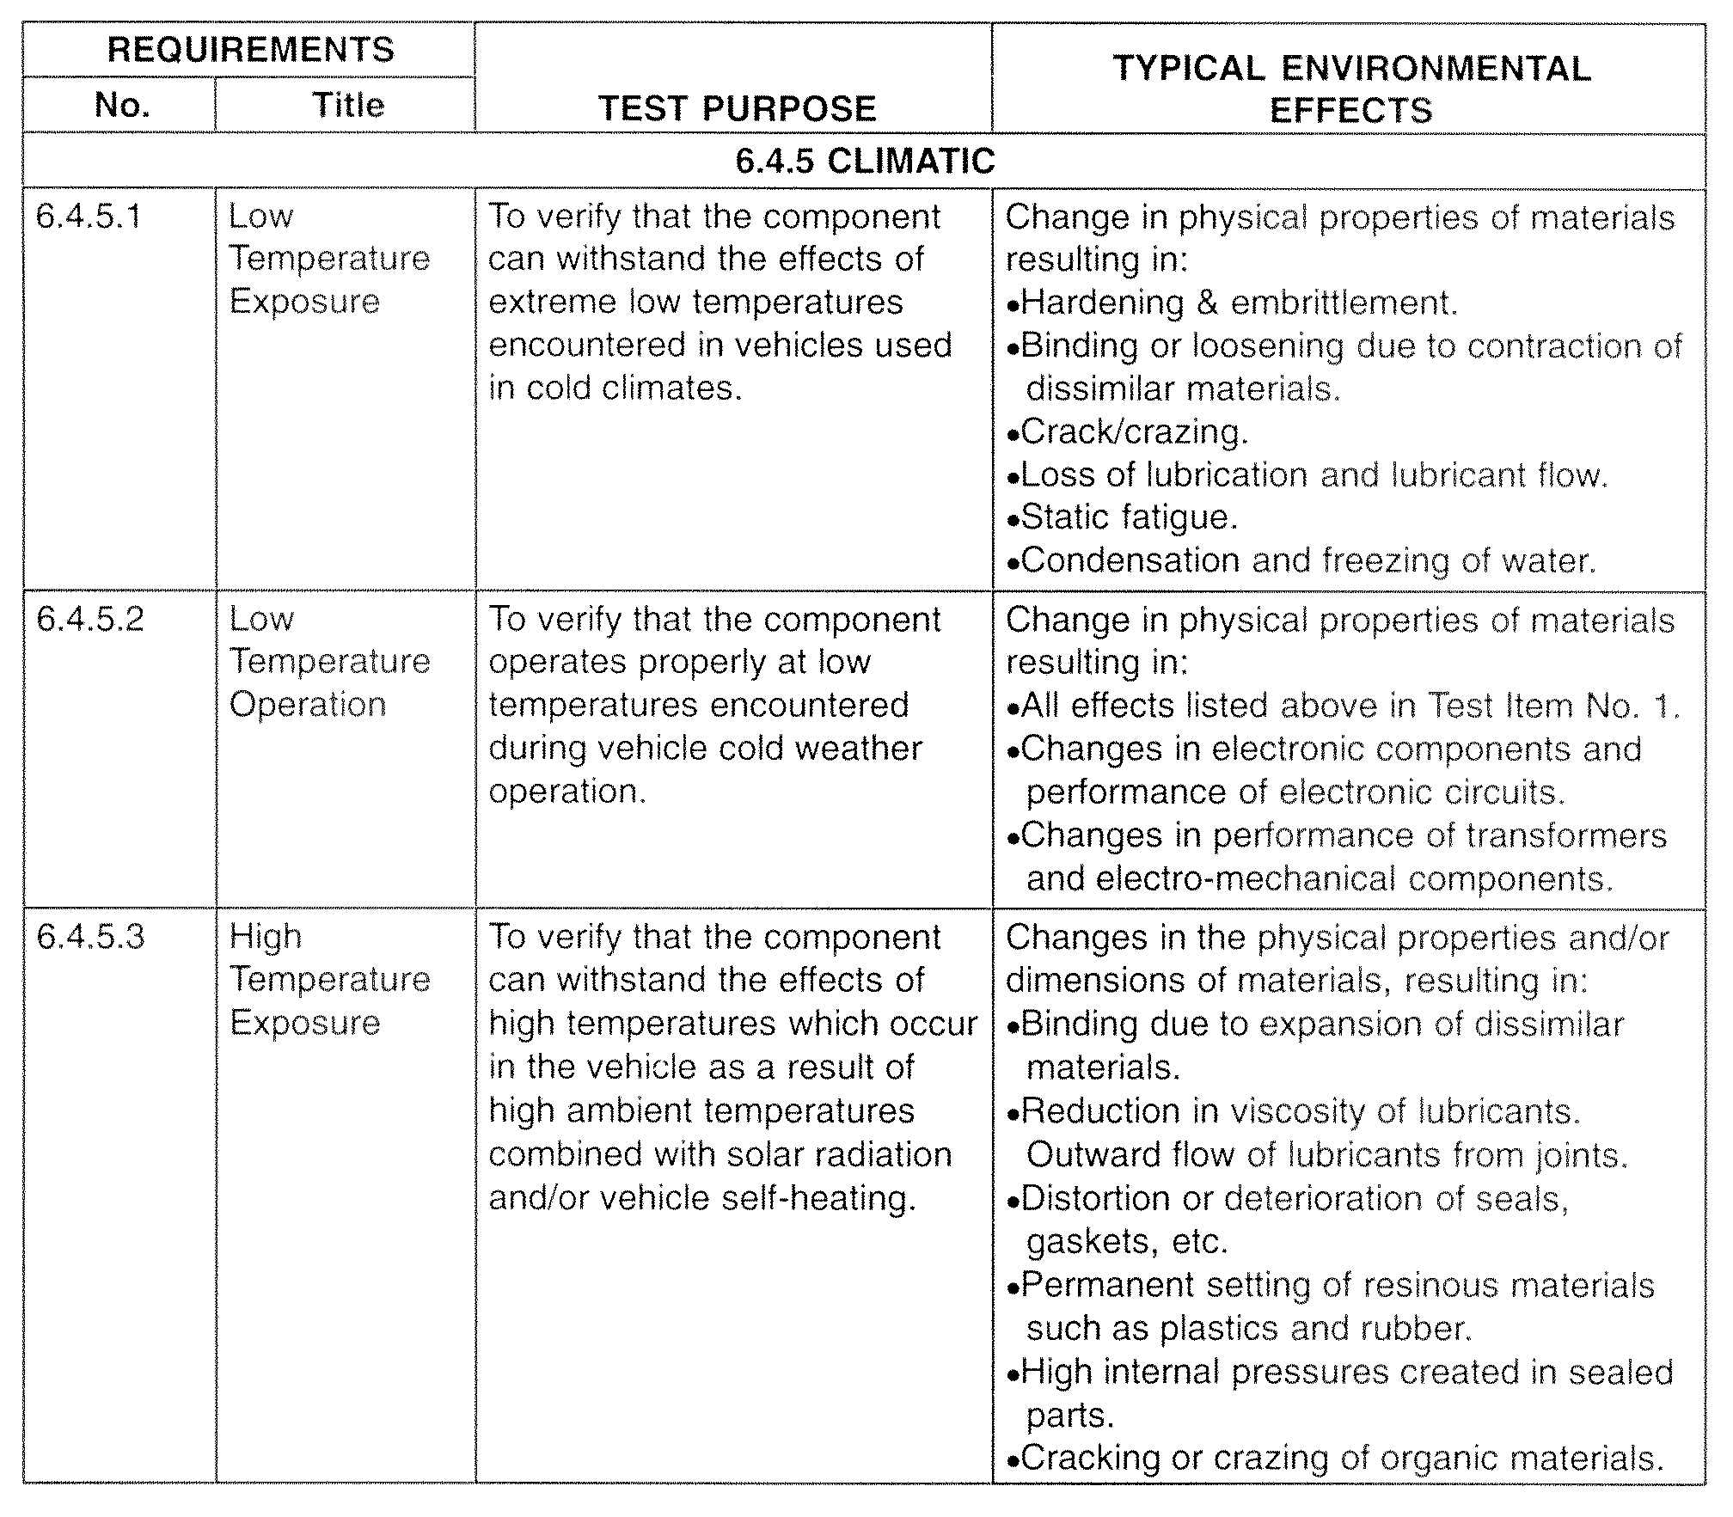

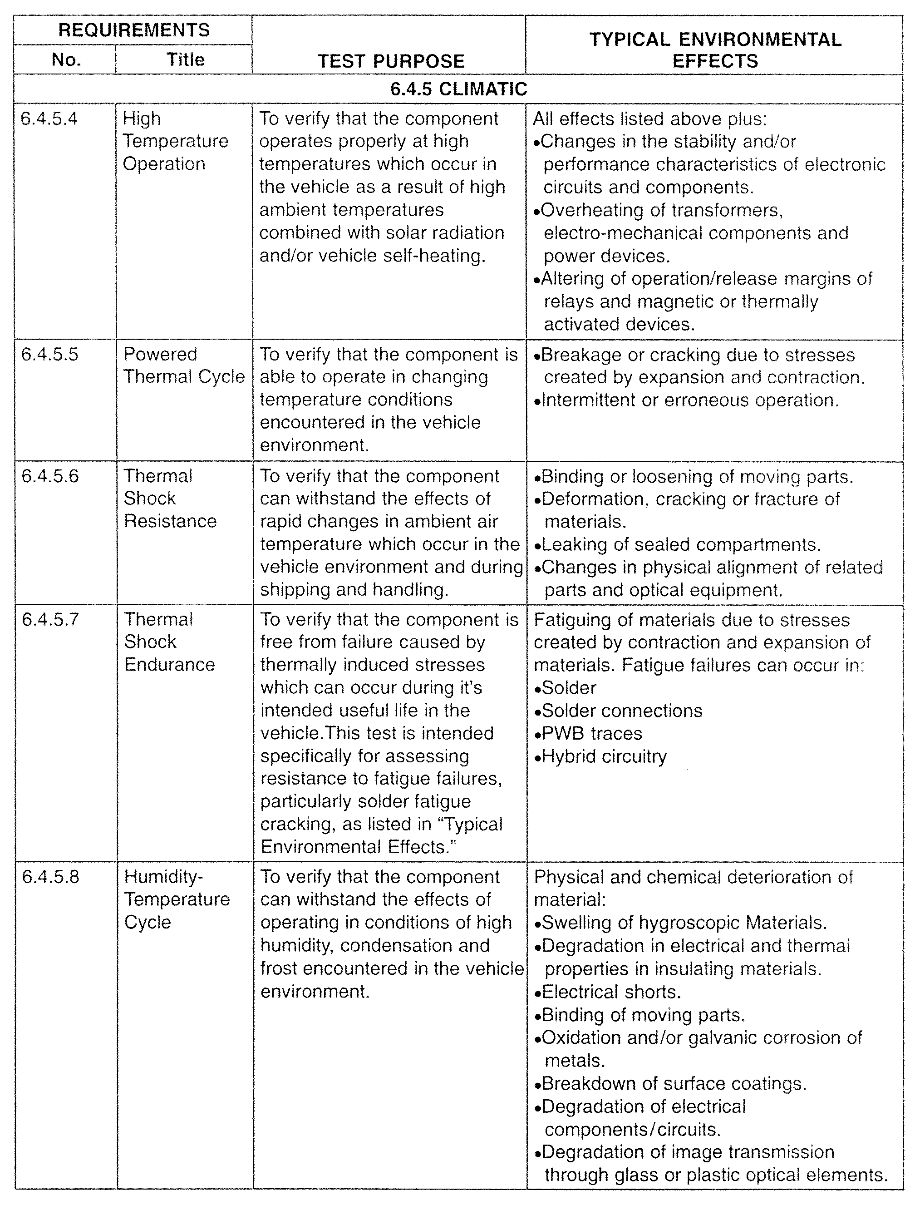

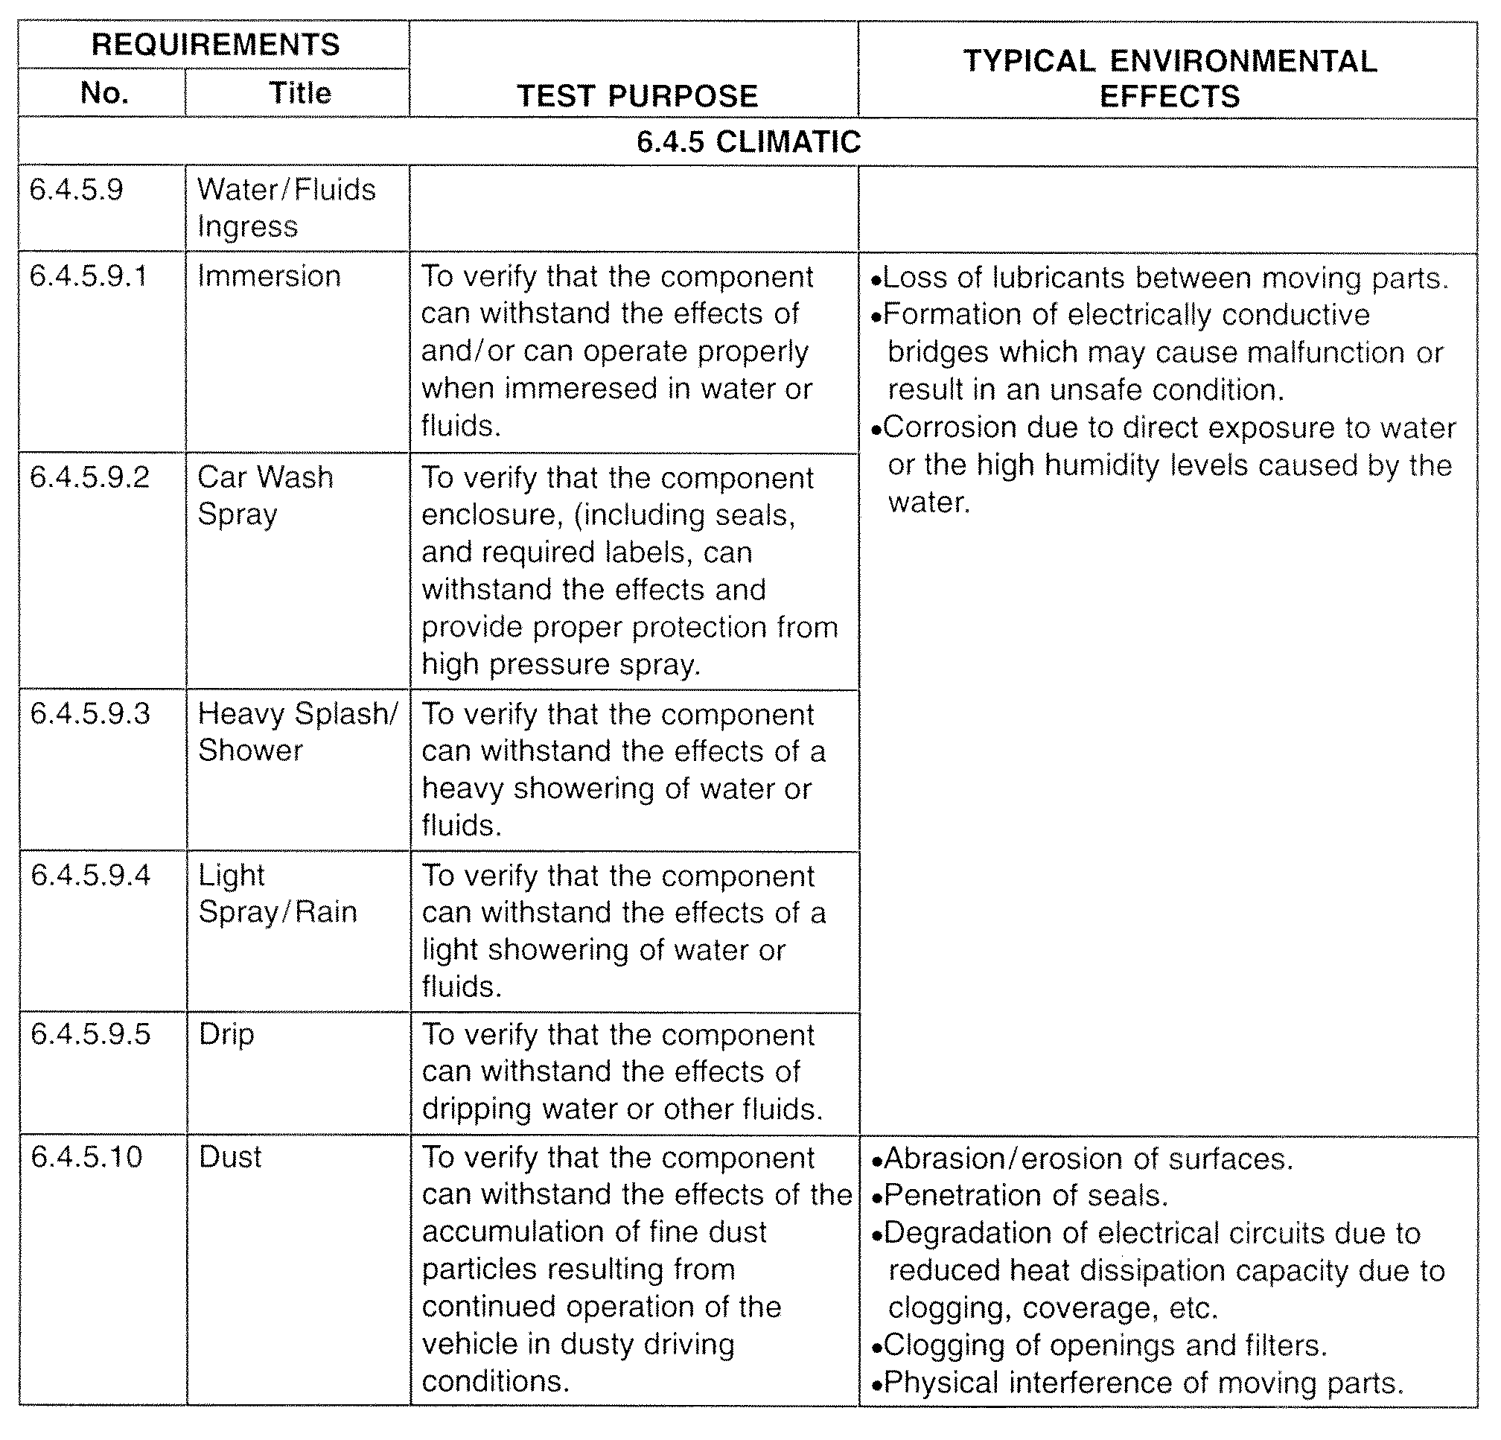

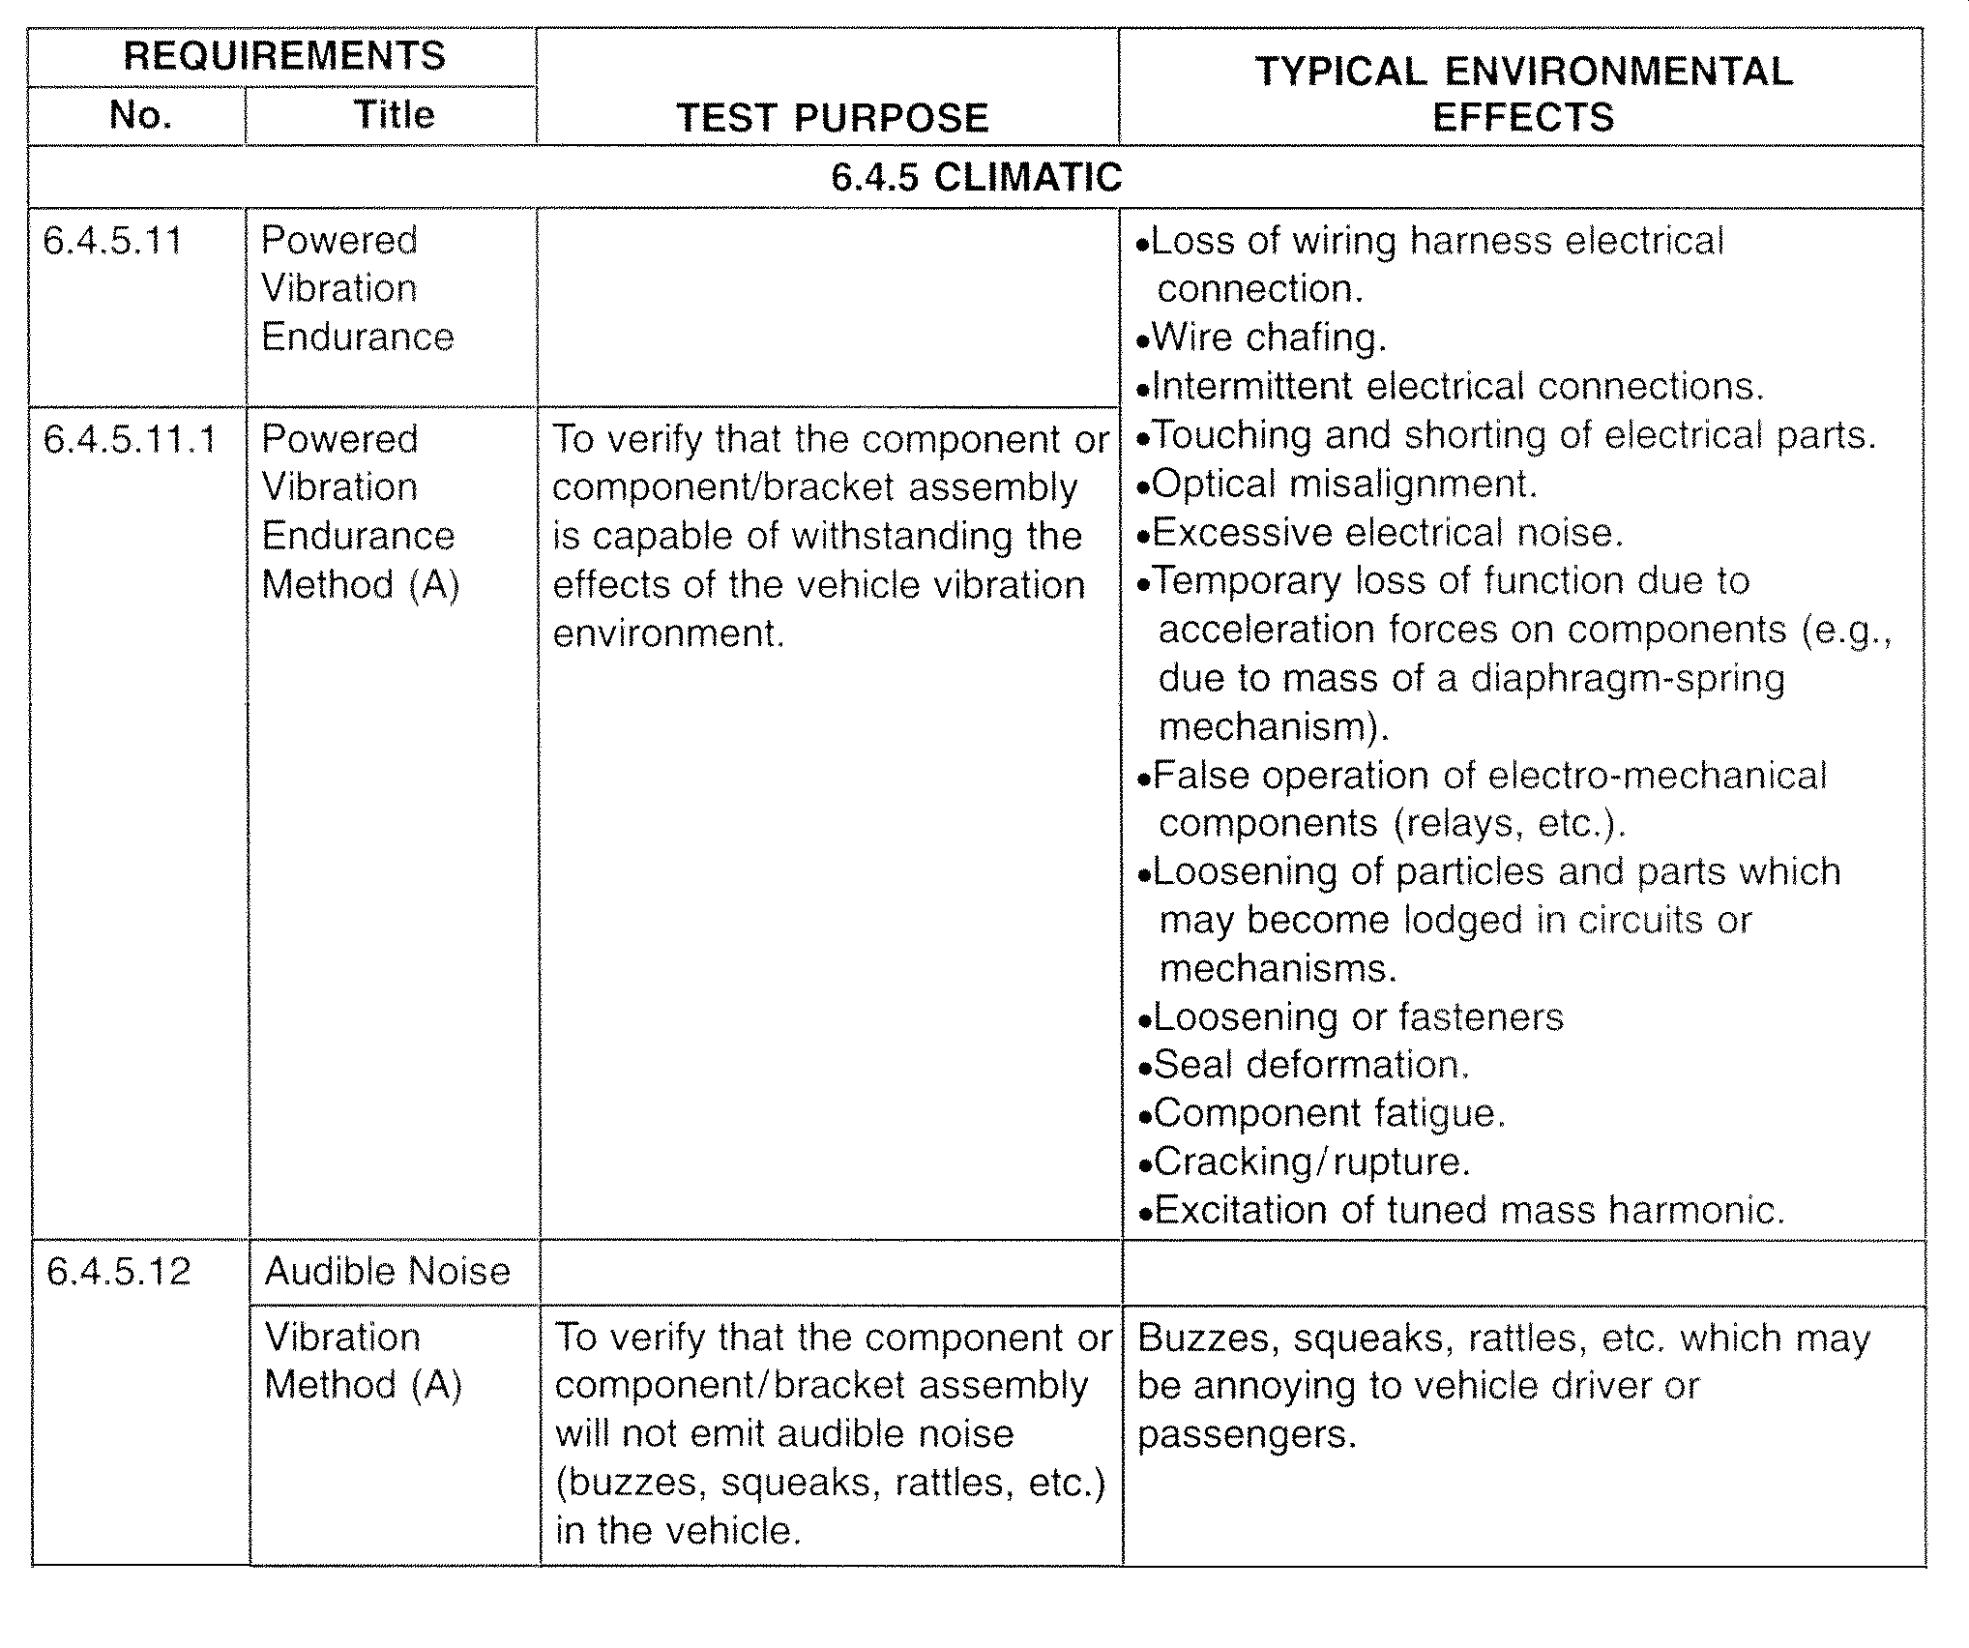

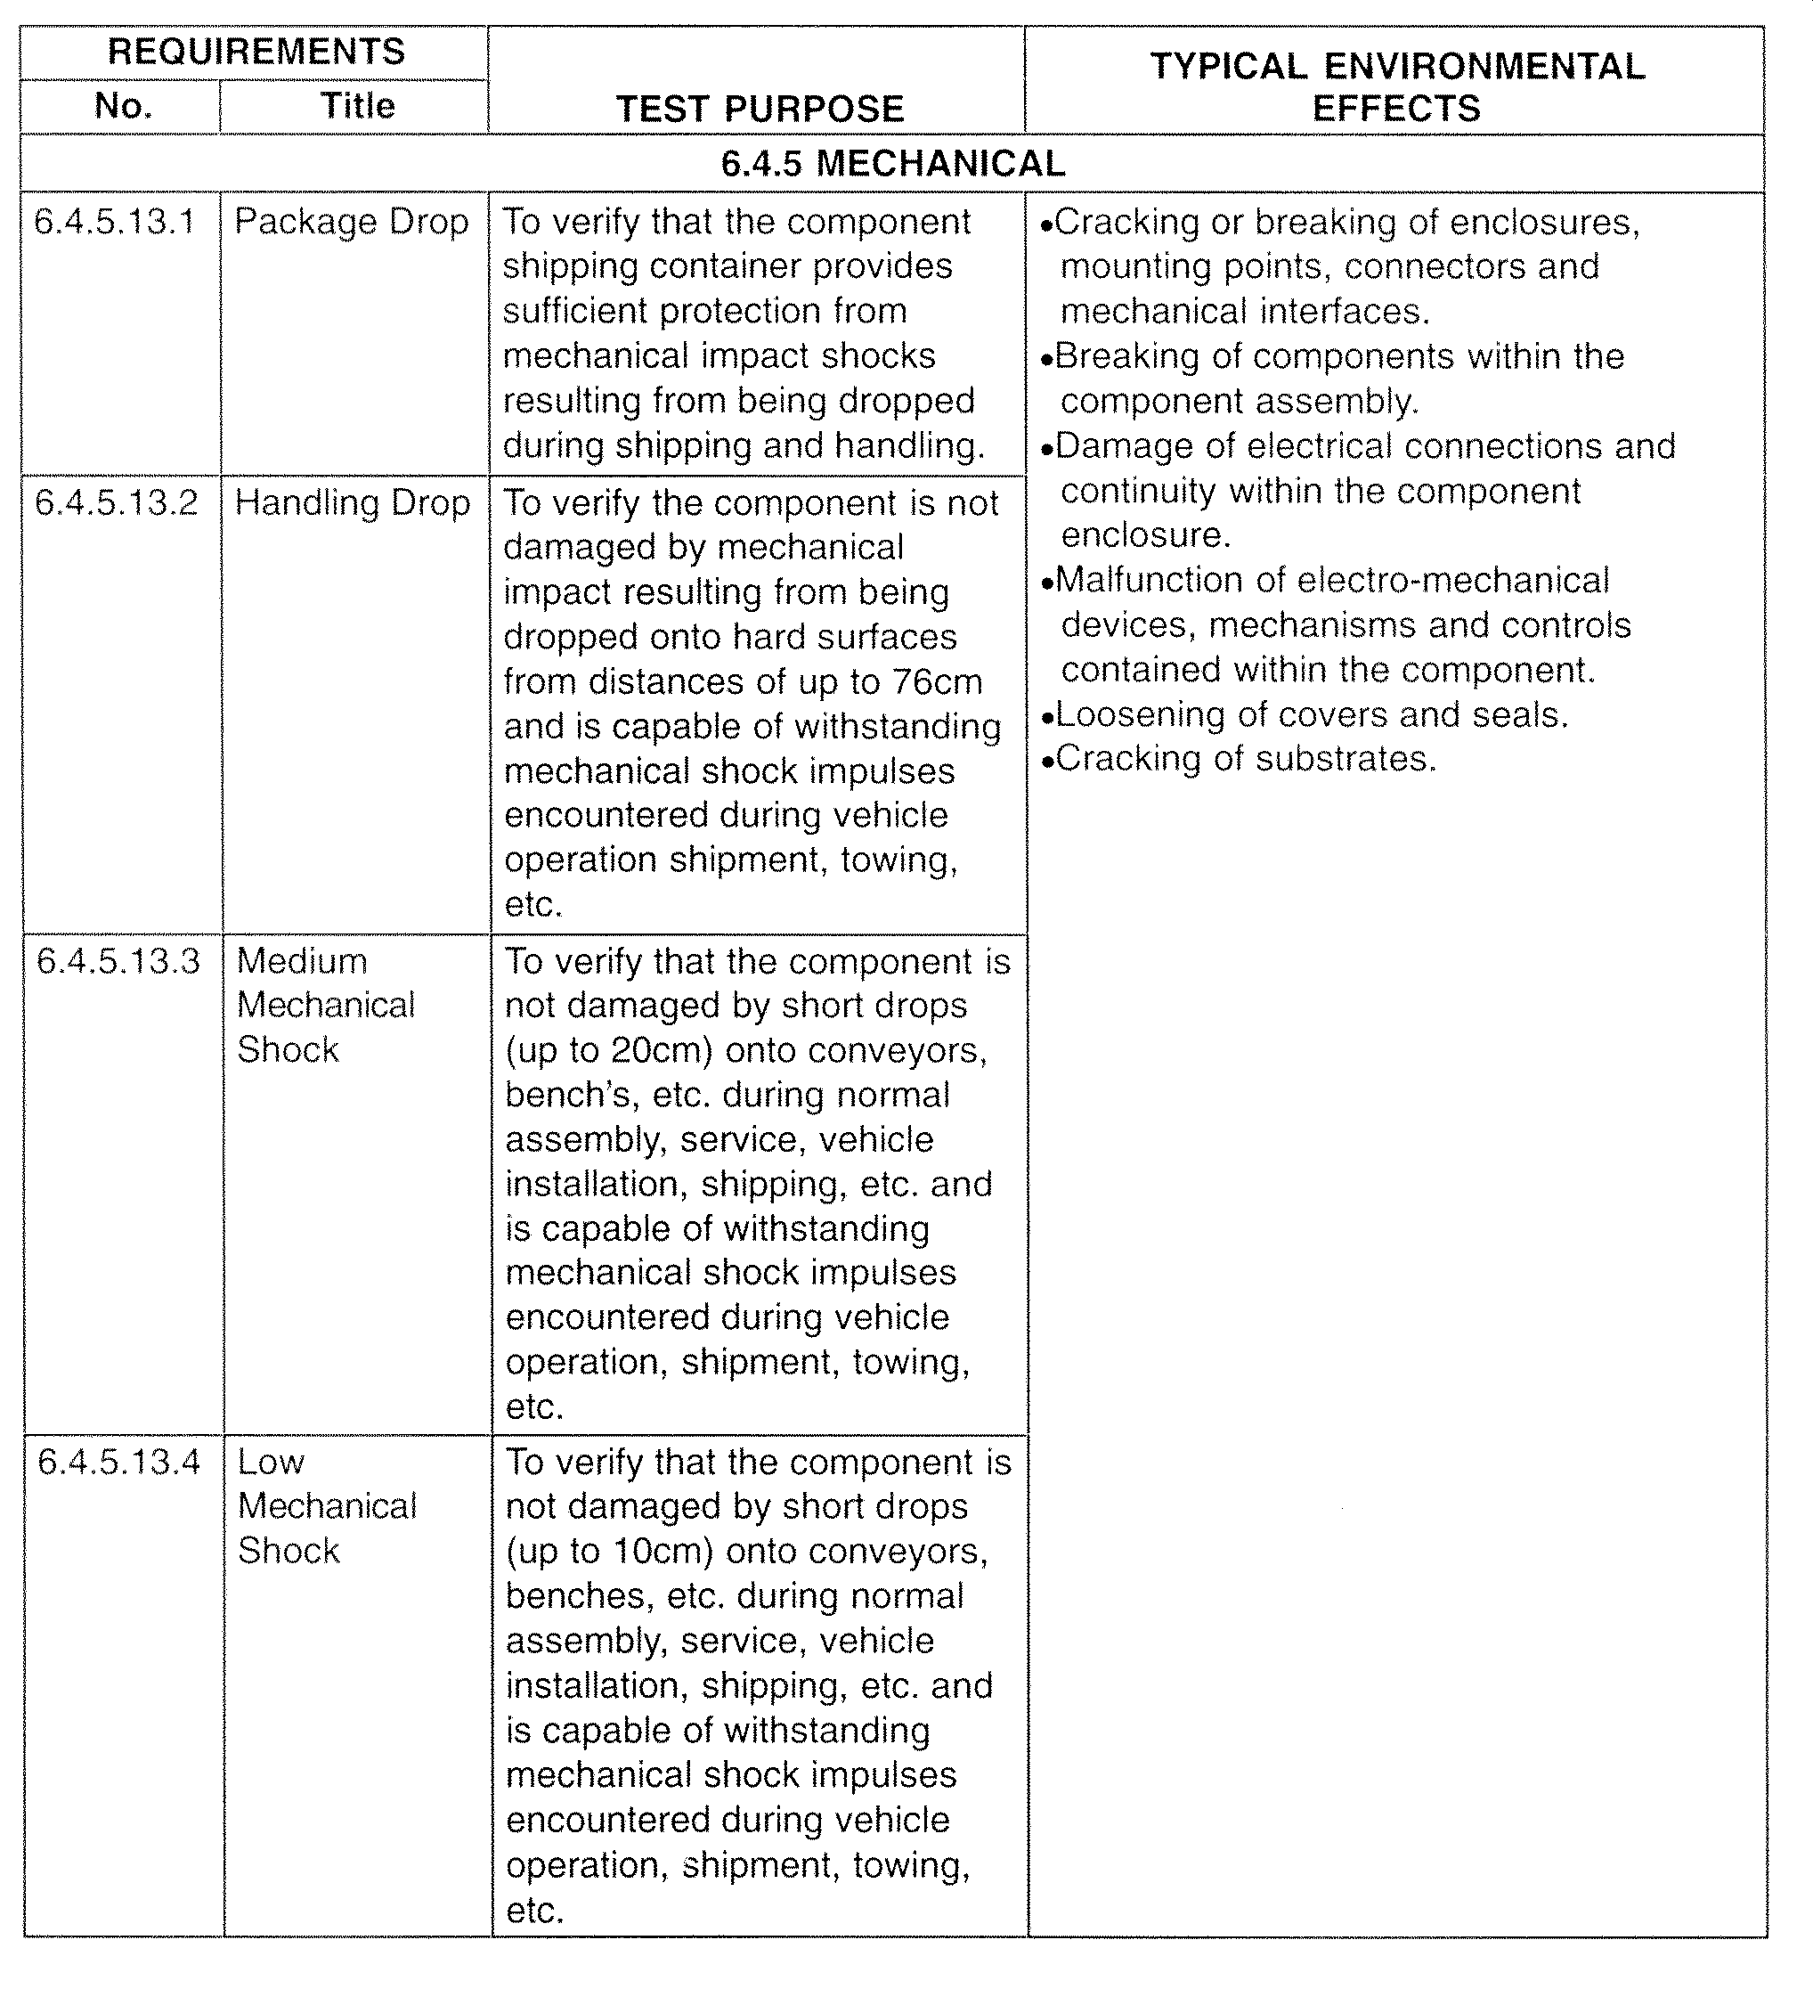

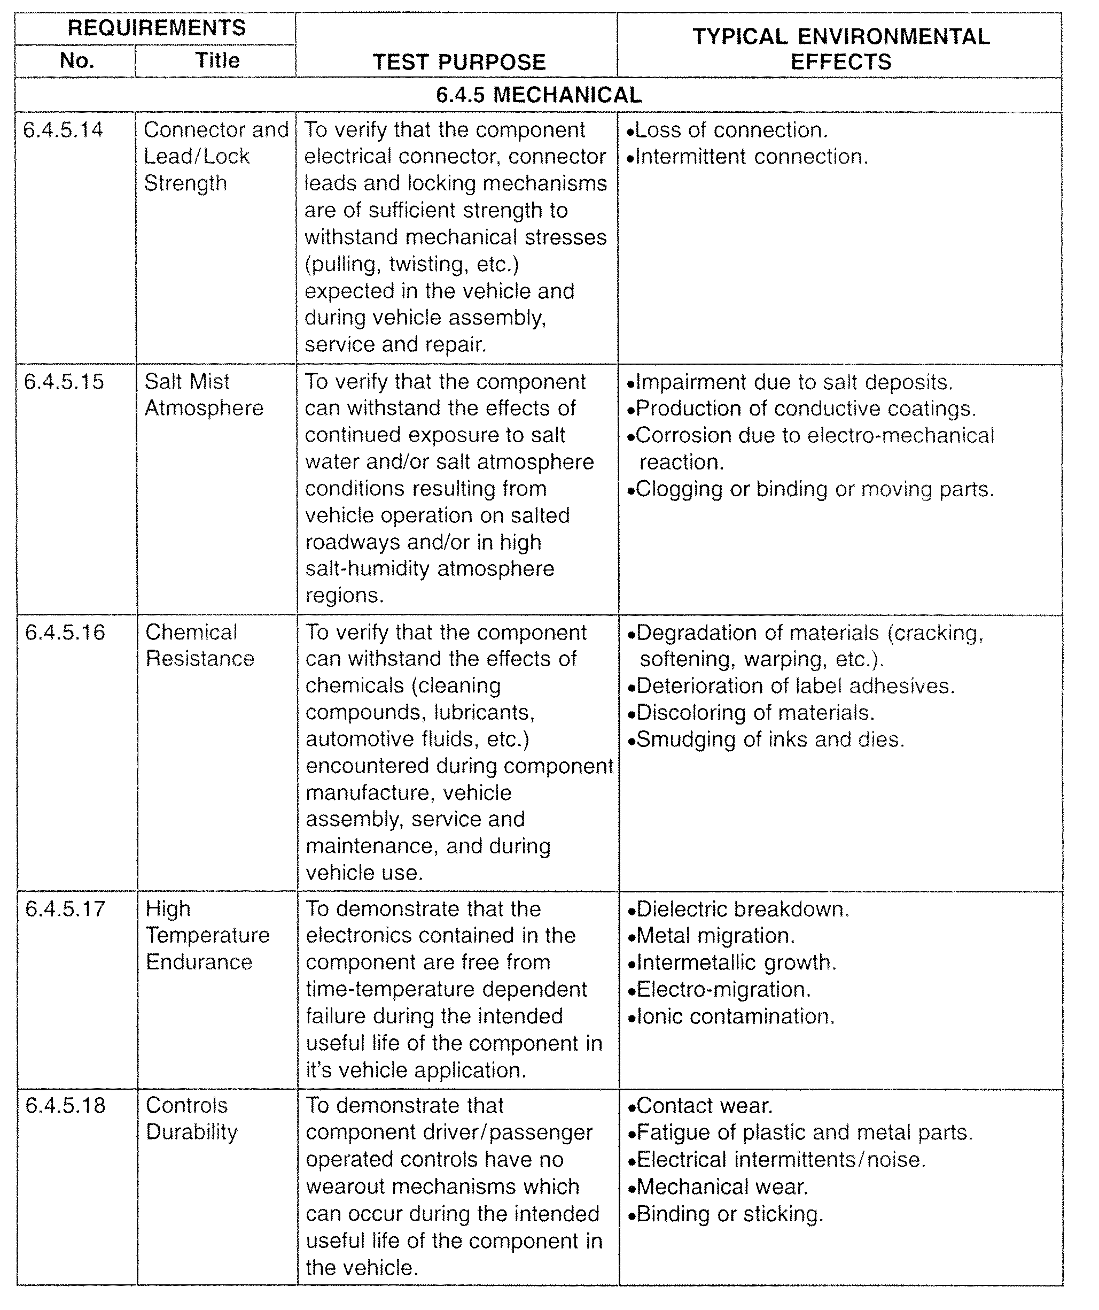

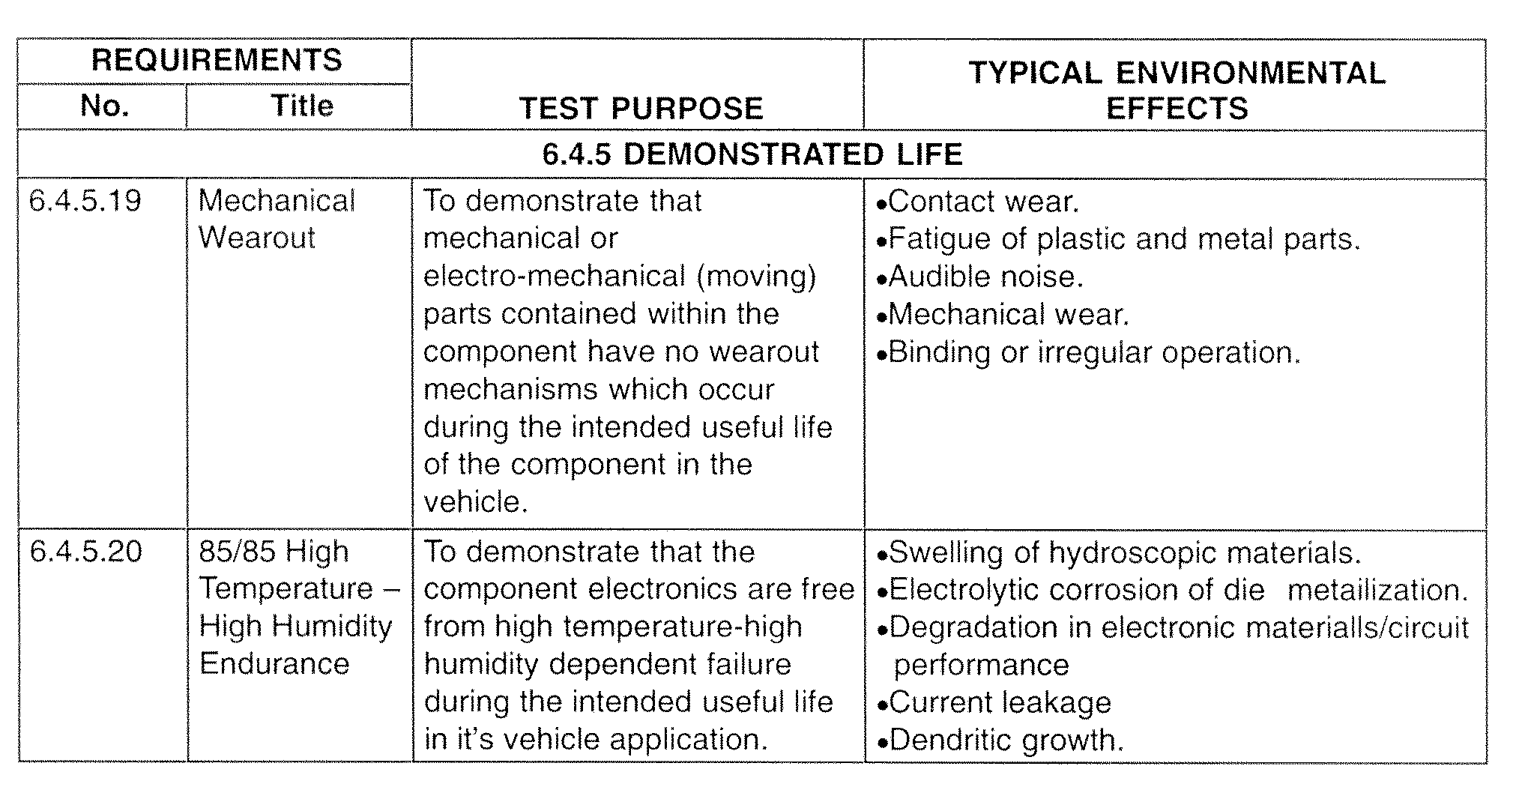

6.5 Test Temperatures
Note 1: Refer to Table 6.7 for description of Temperature Test Classifications.
Description of Location in Vehicle |  |  | Description of Worst Case Maximum Temperature (99th percentile)Conditions and Additional Requirements |  |  | Component  Temperature  Classification  (see Note 1)
 |  |  | Vehicle  Operating  Mode | Temp  (°C) | Comments
Body  Interior | Recessed in instrument panel, console or other enclosed area not exposed to direct sunlight | Near (within 5cm of) upper inner skin/sheet metal areas which are heated by sunlight | Ignition-off desert sun soak with windows / doors closed | 95 | Additional 95°C high temperature exposure testing must be specified for component subassemblies /materials exposed areas indirectly heated by sunlight. | I
 |  | All other areas | Ignition–off desert sun soak with windows / doors closed | 85 | N /A | I
 | Exposed to direct sunlight | Horizontal surfaces having 2 or more hours exposure to direct overhead sunlight during mid–day.  (Examples: Top of IP/rear deck / rear view mirror, sunroof area, horizontal consoles, etc.) | Ignition–off desert sun soak with  windows / doors closed | 105N.A.120G.C. | Additional 105/120°C high temperature exposure testing must be specified for component surfaces and materials and / or component subassemblies heated by exposure to sunlight. | I
 |  | Sloped surfaces having 2 or more hours exposure to direct overhead sunlight during mid–day.  (Examples: Sloping consoles, sloped sections of the IP, sunvisor, steering wheel, etc.) | Ignition–off desert sun soak with  windows / doors closed | 115 | Additional 115°C high temperature exposure testing must be specified for component surfaces and materials and / or component subassemblies heated by exposure to sunlight. | I

Description of Location in Vehicle |  |  | Description of Worst Case Maximum Temperature(99th percentile) Conditions and Additional Requirements |  |  | Component  Component Temperature  Classification  (see Note 1)
 |  |  | Vehicle  Operating  Mode | Temp  (°C) | Comments
Body Interior | Exposed to direct sunlight | Surfaces exposed to direct sunlight at times other than mid–day, i.e., morning and late afternoon only.  (Examples: Door panels, front of IP, etc.) | Ignition–off desert sun soak with windows /  doors closed | 95 | Additional 95°C high temperature exposure testing must be specified for component surfaces and materials and / or component subassemblies heated by exposure to sunlight. | I
 | Floor –  Passenger  Compartment | Near (underbody)  heat source | Desert trailer tow | 115 | Floorpan temperatures can reach 115°C. | IV
 |  | Away from (underbody) heat source | Desert trailer tow | 85 | N /A | I
 | Luggage  Compartment | Away from (underbody) heat source | Idle soak after  desert trailer tow | 85 | N /A | I
 |  | Near shielded  (underbody) heat source | Desert trailer tow | 115 | Floorpan temperatures can  reach 115°C. | IV
Door Interiors (Including Rear Hatch) | Near Top (in upper areas heated by sunlight) |  | Ignition–off desert sun soak with windows /  doors closed | 105 | N /A | III
 | Mid and Lower Portions |  | Ignition–off desert sun soak with windows /  doors closed | 85 | N /A | I
Note 1: Refer to Table 6.7 for description of Temperature Test Classifications.

Description of Location in Vehicle |  |  | Description of Worst Case Maximum Temperature(99th percentile) Conditions and Additional Requirements |  |  | Component  Temperature  Classification  (see Note 1)
 |  |  | Vehicle  Operating  Mode | Temp  (°C) | Comments
Body  Exterior | Outer Body Exterior  (including bumpers, side view mirrors, roof, etc.) | Exposed to direct sunlight | Desert sun soak | 105N.A. 120G.C. | Additional 105/120°C high temperature exposure testing must be specified for component surfaces and materials and / or component subassemblies heated by exposure to sunlight. | I
 |  | Protected from direct sunlight | Desert sun soak | 85 | N/A | I
 | Under–Body (Including Suspension) | Near Trans. or Differential | Idle soak after desert trailer tow | 125 | N/A | V
 |  | Away from heat source | Idle soak after desert trailer tow | 85 | N/A | I
 |  | Near Exhaust (with protection) | Desert trailer tow | 150 | N/A | VI
 | Near Brake Pad/Rotor |  | Desert trailer tow (downhill braking) | 150 | N/A | VI
Engine  Compart–  ment | Away from  Heat Source | Well ventilated with cool air from outside engine compartment | Idle soak after desert trailer tow | 95 | N/A | II
 |  | Well Ventilated | Idle soak after desert trailer tow | 115 | N/A | IV
 | Near heat source |  | Idle soak after desert trailer tow | 150 | N/A | VI
 | Electric Vehicle |  | Desert sun soak | 85 | N/A | I
Note 1: Refer to Table 676 for description of Temperature Test Classifications.

6.6 Vehicle Supply Voltage Ranges
Component Test Voltage | Function Performed with Engine Running |  | Functions Performed with Ignition Off  (Battery Supply Only)
 | Requirement for Component in the Vehicle Application | Voltage (V_{DC}) (See Note 1) | Requirement for Component in the Vehicle Application | Voltage (V_{DC}) (See Note 1)
V₁  Low Voltage of  Guaranteed  Function | *1. Must remain functional in a stalled or near–stall engine idle conditions. | 6 | 1. Must remain functional when battery is in a low state of charge | 9 or 10
 | *2. Must remain functional during all engine idle conditions including when vehicle electrical load exceeds charging system capacity. | 8 or 9 | 2. Loss of function is acceptable when battery is in a low state of charge or under heavy electrical load. | 11
 | *3. Loss of function is acceptable under condition described in (1) and (2) above. | 10
V₂  High Voltage of Guaranteed  Function | *1. Must function during engine warm–up period after cold start (-30°C to -40°C). | 16 or 15.5 | 1. Must remain functional when a battery charger is connected to the charging system. | 16 or 15
 | *2. Function not required during engine warm–up period after cold start (-30°C to -40°C). | 15.5 or 15 | 2. Loss of function is acceptable when a battery charger is connected to the charging system. | 14
V₃  Low Voltage of  Guaranteed  Performance | *1. Must perform to specification in a stalled and/or near–stalled engine condition. | 6 or 7 | 1. Must perform to specification when the battery is in a low state of charge. | 10 or 11
 | *2. Must perform to specification during all idling conditions. (including cases when electrical load exceeds charging system capacity. | 8, 9 or 10 | 2. Performance to specification is not required when the battery is in a low state of charge. | 11
 | *3. Performance to specification not required under conditions. (1) and (2) above.* | 10, 11 or 12
V₄  High Voltage of Guaranteed  Performance | *1. Must perform to specification during engine and warm–up period after cold start (-30°C to -40°C). | 16, 15.5 or 15 | 1. Must perform to specification when a battery charger is connected to the vehicle charging system. | 16 or 15
 | *2. Performance to specification not required during warm–up period after cold start (-30°C to -40°C). | 15 or 14.5 | 2. Performance to specification is not required when a battery charger is connected to the vehicle charging system. | 14 or 13
V_{N}  Nominal Operating Voltage | Same for all components. | 13.5 | Same for all components. | 12.5
Note 1: Select the most appropriate component test voltage requirement (for V₁, V₂, V₃, V₄ and V_{N}) from the table while also considering the following items:
a. Component and subsystem Function Safety Classification and Functional Performance Classification.
b. Subsystem configuration and component requirements for orderly shut down at low voltage, fault tolerance, etc.
c. The charging system performance characteristics for all vehicle applications and operating conditions (also see Table 3.2.6(a)).
d. Voltage drops which may be expected in wiring/distribution systems in all vehicle applications.
e. Value selected for V₃ must be ≥ V₁.
f. Value selected for V₄ must be ≤ V₂.
g. Subsystems/components required to operate when the engine is running and not running must meet both requirements; ie., Voltages must be specified considering both sides of the table appropriately.
Note 2: V₁XV₄,V_{N} voltage tolerance is ± 0.2V.
Note 3: Functional Check Test Voltage V₅ = V_{N} ± 1.5V, Monitored Operation Test Voltage V₆ = V_{N} ± 0.5V.
*This condition is considered normal and can be expected to occur occasionally in any vehicle.

6.6 Vehicle Supply Voltage Ranges cont.

Common service
practice (in North
America) to recharge battery.
Often.
Occasionally.
Occasionally.
Up to 16V is possible when a battery charger is connected to the vehicle
charging system.
Normal voltage range for a battery with a normal state of charge and typical electrical loading.
Battery is in a low state of charge or is
under heavy electrical loading.
(Will still start engine).
Battery is in a low state of charge and may have dead cells. (Will not start engine if below approx. 10.5V).
Highest voltage regulation occurs during engine warm–up periods following cold starts at extreme low temperatures.
Normal driving and idling with typical electrical system loading.
System voltage drops out of regulation when electrical load exceeds charging system capacity.
In engine stall or near–stall conditions system voltage may dip below 9 volts and then return to a steady state condition.
Common during
winter in cold
climates.
Common when
idling in gear with accessories in use.
Often.
Rare. Extreme loading.
Very Rare.
16
15.5
15
14
13
12
11
10.5
9
8†
7
6
† Engines are usually not guaranteed to run below 8V.
* Voltage at the component will be equal to or lower than the voltage at the battery depending on the amount of voltage drop within the wiring distribution system. Voltage ranges given are approximate (±0.5V to ±0.75V). Actual voltage will depend on individual vehicle design and varies with normal production variation in charging system component characteristics.
Description of Vehicle Conditions
Frequency of
Occurrence
Vehicle Operating Condition
Frequency of Occurrence
System
Voltage (V_{DC})
Measured at
Battery*
Vehicle Operating Condition
Engine Not Running (Battery supply only)
Ignition–On/Engine Running

6.7 Temperature Classifications
Component  Temperature  Classification | Test Temperatures (°C)
 | Exposure Tests |  | Operation Tests  (See Note 3) |  | Performance Tests |  | Functional EvaluationTests
 | T₅  (Min.) | T₆  (Max.) | T₁  (Min.)  (See  Note 1) | T₂  (Max.) | T₃  (Min.)  (See  Note 1) | T₄  (Max.)  (See Note 2) | T₁  (Min.) | T₇  (Max.)  (See Note 2)
I | - 40 | 85 | - 40 | 75 | As necessary to meet performance requirements for component/  subsystem | As necessary for specific location of component in vehicle and to meet performance requirements for component/  subsystem. | - 40 | As necessary for specific location of component in vehicle and to meet functional requirements for component/  subsystem.
II | - 40 | 95 | - 40 | 85 |  |  | - 40
III | - 40 | 105 | - 40 | 95 |  |  | - 40
IV | - 40 | 115 | - 40 | 105 |  |  | - 40
V | - 40 | 125 | - 40 | 115 |  |  | - 40
VI | - 40 | 150 | - 40 | 140 |  |  | - 40
VII (vehicle data available/special  case/ more severe) | As agreed by supplier and user |  |  |  |  |  | As agreed by supplier and user
Note 1: -30°C may be specified for radio tuner and amplifier assemblies and other electronic components located thorough out the vehicle.
Note 2: When specifying component high temperature performance and functional requirements, consider the additional information and comments given in Table 6.4 regarding maximum temperature conditions and vehicle operating mode.
Note 3: Minimum and maximum operation temperatures for cassette players, CD players,
and other multi-media/entertainment system and other electronic components may be determined based on technology limitations, competitive assessment data, customer usage requirements and/or expectations and any applicable corporate, government or industry standards. If the minimum operating temperature is greater than T1 and/or the maximum operating temperature is less than T2 then the Performance Test and Functional Evaluation tests may be used.
Note 4: All room temperature evaluations shall be performed at temperature T_{N} = 20±15°C.

6.8 Water/Fluid Ingress Classifications  Vehicle Location |  |  | Severity  Classifications for Fluids  Ingress | Test Method Requirements
Description |  |  |  | 4.5.9.1  Immer  sion | 4.5.9.2  Car  Wash  Spray | 4.5.9.3  Heavy Splash/  Shower | 4.5.9.4  Light  Splash/ Rain | 4.5.9.5  Drip | 4.5.9  Tests N/A
Underbody & Lower Part of Engine Compartment( located under the submerge line for vehicle application) |  |  | VIII | X | X
Vehicle Exterior, Middle and Upper Part of Engine Compartment | Area of direct road splash or rain  ( located under the submerge line for vehicle application) |  | VI |  | X | X
 | Area out of direct path of road splash or rain |  | V |  | X |  | X
Vehicle Interior and Luggage Compartment | Low Lying Areas  ( located under the submerge line for vehicle application) |  | VII | X
 | Other Areas | In area of direct light spray | III |  |  |  | X
 |  | Out of path of direct spray | II |  |  |  |  | X
 |  | Area of guaranteed protection from immersion, splash and drip. | I |  |  |  |  |  | X
Inside Doors | Lower portion of door where water may  accumulate |  | VII | X
 | Middle and  Upper Portions | In direct path of heavy splash or rain | IV |  |  | X
 |  | In direct path of light splash or spray | III |  |  |  | X
 |  | Out of path of direct splash or spray | II |  |  |  |  | X
 |  | Areas of guaranteed protection from immersion, splash and drip. | I |  |  |  |  |  | X
Note 1:
It is possible that components may be located in more severe areas of the vehicle if sufficient protection (drip hoods, splash shields, etc.) are incorporated into the vehicle design. However, such decisions should be based on careful analysis by the component designer (supplier) and the vehicle system engineer (user). Furthermore, such cases should be handled on an exception basis and documented appropriately to prevent the possibility that the protection may be removed at a later date.
✶ See Figure 1 and Figure 2 for pictorial representation.
✴ For a component to be classified in classification I “Area of guaranteed protection from immersion, splash and drip” the following conditions must be met:
1. The component is always located in the same location in all vehicle applications.
2. The vehicle design configuration in all applications is such that it is not possible that water may be splashed or dripped (including dripping from excess condensation on A/C ducts) on to the component under any circumstances.
3. The vehicle design configuration is not such that it may be considered to fall into the category described in Note 1 above.
Severity Classifications for Fluids Ingress for cassette player assemblies, CD players, video displays, cellular phones and other entertainment system components should be determined based on competitive assessment data, customer expectations and any applicable corporate, government or industry standards, but must still be evaluated based on the vehicle locations.
Figure 1. Water/Fluid Ingress Classifications
Note: Area under a leather seat is considered a Classification I

CAR
III
TRUCK
VAN
III
III
III
III
III
III
III
III
III
VIII
VIII
VIII
VIII
VIII
VIII
VII
VII
VII
VII
VII
VII
VII
VII
VII
VII
VII
V or VI
V or VI
V or VI
II
II
II
II
II
II
II
II
II
II
II
II
II
I
I
I
submerge level
submerge level
submerge level

Figure 2. Water/Fluid Ingress Classifications

LIFTGATE
GLASS
III
II
III
IV
WATER SHIELD
III
III
VII
II
GENERAL DOOR/LIFTGATE OR MOVEABLE GLASS
LIFTGATE WITH HINGED GLASS
II
III
IV
VII
expected water fill level
Table 6.9 Salt, Dust and Chemical Resistance Classifications
Description of  Location in Vehicle | Classifications
 | Test Method 4.7.1 Salt Mist Atmosphere |  | Test Method 4.5.10  Dust |  | Test Method 4.7.2 Chemical Resistance
 | Classi–  fication | Test  Duration | Classi–  fication | Dust  aggitation | Classi–  fication | List of Chemicals (See Note 1)
Engine Compartment | IV | 168 hours or longer (see Note 2) | II | Every three minutes for 20 seconds. | I | 1. Engine oil  2. Transmission fluid  3. Brake fluid (near brake & ABS systems)  4. Coolant  5. Window washer fluid  6. Grease  7. Soap for cleaning engine compartment  8. Battery acid (near the battery only, Note 3)  9. Clear Lacquer  10. CaCl2 (Calcium Chloride)
Note 1: Applicable chemicals should be appropriately selected from the below lists based on analysis of vehicle environmental conditions, all possible vehicle design configurations and/or FMEA. The list of applicable chemicals and relevant component surface(s) to be tested must be specified in the component drawing and/or specification.
Note 2: Appropriate duration shall be selected based on component FMA, FMEA and/or component functional and appearance requirements with respect to corrosion resistance.
Note 3: 'Near the battery' is defined as any location that is within a radius of 200 mm from the center of the battery and below the top of the battery.

Table 6.9 Salt, Dust and Chemical Resistance Classifications cont.
Description of  Location in Vehicle |  | Classifications
 |  | Test Method 4.7.1 Salt Mist Atmosphere |  | Test Method 4.5.10  Dust |  | Test Method 4.7.2 Chemical Resistance
 |  | Classi–  fication | Test  Duration | Classi–  fication | Dust  Concentration | Classi–  fication | List of Chemicals (See Note 1)
Lower Exterior Body and Underbody |  | IV | 168 hours or longer (see Note 2) | III | Every one minute for 20 seconds. | II | 1. Kerosene  2. Fuel (including gasoline, methanol, etc)  - near fuel filler door, fuel lines, etc. only  3. Leather wax  4. Car wax and silicone protectants  5. Window glass cleaner  6. Car wash soap  7. Window washer fluid  8. Damper oil (near air suspension valve or height control system)  9. CaCl2 (Calcium Chloride)
Upper Exterior Body |  | III | 48 hours | II | Every three minutes for 20 seconds.
Vehicle Interior | Floor  area | II | 24 hours | I | Every 120 minutes for 20 seconds. | III | 1. Leather wax  2. Anti–mist spray  3. Soap for cleaning  4. Deodorizer spray  5. Coffee, tea, cola, etc.
 | Other | I | N/A | I | Every 120 minutes for 20 seconds. | III | 1. Leather wax  2. Anti–mist spray  3. Soap for cleaning  4. Deodorizer spray  5. Coffee, tea, cola, etc
Note 1: Applicable chemicals should be appropriately selected from the below lists based on analysis of vehicle environmental conditions, all possible vehicle design configurations and/or FMEA. The list of applicable chemicals and relevant component surface(s) to be tested must be specified in the component drawing and/or specification.
Note 2: Appropriate duration shall be selected based on component FMA, FMEA and/or component functional and appearance requirements with respect to corrosion resistance.
Table 6.9 Salt, Dust and Chemical Resistance Classifications cont.
Description of  Location in Vehicle |  | Classifications
 |  | Test Method 4.7.1 Salt Mist Atmosphere |  | Test Method 4.5.10  Dust |  | Test Method 4.7.2 Chemical Resistance
 |  | Classi–  fication | Test  Duration | Classi–  fication | Dust  Concentration | Classi–  fication | List of Chemicals (See Note 1)
Luggage  Compart–  ment | Floor  Area | II | 24 hours | I | Every 120 minutes for 20 seconds. | IV | 1. Engine oil  2. Coolant  3. Window washer fluid  4. Grease  5. Battery acid (near the battery only, Note 3)  6. Kerosene  7. Fuel (near fuel filler door)  8. Window glass cleaner  9. Cleaning soap
 | Other | I | N/A | I | Every 120 minutes for 20 seconds. | III | 1. Leather wax  2. Anti–mist spray  3. Soap for cleaning  4. Deodorizer spray  5. Coffee, tea, cola, etc
Note 1: Applicable chemicals should be appropriately selected from the below lists based on analysis of vehicle environmental conditions, all possible vehicle design configurations and/or FMEA. The list of applicable chemicals and relevant component surface(s) to be tested must be specified in the component drawing and/or specification.
Note 2: Appropriate duration shall be selected based on component FMA, FMEA and/or component functional and appearance requirements with respect to corrosion resistance.
Note 3: 'Near the battery' is defined as any location that is within a radius of 200 mm from the center of the battery and below the top of the battery.

6.10 TERMINOLOGY.
6.01.1 Accelerated Test. A test which accelerates the wear or deterioration of an item by subjecting it to environmental stresses and/or loading conditions beyond those normally encountered in it’s application and/or by increasing the frequency with which loads or stresses are applied during normal use. Accelerated tests are typically conducted at or above maximum stress or loading conditions for which the item is rated. Accelerated test methods are useful in attribute testing, life testing, reliability testing and development testing.
6.10.2 Accelerated Life Test. An Accelerated Test specifically designed and conducted with the intent of obtaining failure rate, time-to-failure and/or cycles-to-failure data or to obtain information useful in determining or understanding failure modes and mechanisms.
6.10.3 Attribute Test. A test which verifies that an item has a specific attribute or set of attributes (e.g., operates as specified at -30 °C, has 1000 hours life at max. rated temperature, etc.). Qualification, Certification, Design Verification, Production Validation, In-Process, Demonstrated Life and Reliability Demonstration tests are all examples of attribute tests. Attribute tests are usually specified as a “requirement” on engineering drawings, specifications and/or contractual agreements and thus form the basis for establishing design requirements.
6.10.4 Audit Test. A test performed on a sample of items (incoming material, manufactured parts, process equipment, etc.) to verify compliance with a standard, practice, procedure or specification.
6.10.5 Burn-in. A test, usually conducted on production parts at the manufacturing facility, which is used for the purpose of screening out substandard (weak) product, auditing quality levels and/or to help gain information useful in improving quality levels. Typically, in a Burn-in test, production parts are operated continuously at maximum or above maximum rated power or voltage at ambient temperature or maximum rated temperature. The test duration is usually between 8 and 48 hours depending on the nature of product failure mechanisms, test acceleration factors and desired quality levels.
6.10.6 Demonstrated Life Test. A life test method which specifies a predetermined number of hours and/or cycles as a bogie or “pass” criteria. Demonstrated Life Test “pass” criteria is established through correlation to vehicle environmental conditions and 10 year/150,000 mile duty cycles or according to requirements or recommended practice defined in corporate or industry standards.
6.10.7 Design Verification (DV). The act of determining the vehicle environment (temperature, vibration, duty cycles, loads, etc.) and defining and conducting all tests and evaluations necessary to assure the adequacy of a design for the vehicle environment. The process for Design Verification is defined in Ford Automotive Procedure FAP 03-149, Product Verification Specification (PV SPEC).
6.10.8 Design Verification Plan (DVP). A test plan, completed per Ford Corporate form CEG-7184 ”Design Verification Plan & Report” format, which list all tests and evaluations, acceptance criteria, timing and sample size requirements for Design Verification of a specific product design or design level.
6.10.9 Design Verification Report (DVR). A report, completed per Ford Corporate form CEG-7184 “Design Verification Plan & Report” format, documenting Design Verification test results and actual test completion dates.
6.10.10 Design Verification Plan & Report (DVP&R).
a. Ford corporate form CEG-7184 “Design Verification Plan and Report,” FAP 03-149, Product Verification Specification, used for documenting Design Verification plans and reports.
b. A design verification plan and report for a specific product or product design level.
6.10.11 Design Verification (DV) Test.
a. Any test specified in a Product Verification Specification (PV Spec) or Design Verification Plan & Report (DVP&R) which is intended for use in verifying a design attribute.
b. A non-standard test procedure (ie. not published in an authoritive document such as ES, CETP, SAE, MIL-STD, IEC, ASTM, etc.), which is documented on Ford Corporate forms PD-7185 and PD-7185a and specified in a PV Spec and/or DVP&R.
6.10.12 Development Testing. Informal testing performed for developmental purposes during the developmental stages of a program, typically to gain insight into product design attributes such as operating limits, robustness to environmental conditions, etc.. Examples of development testing include step-stress testing, characterization testing, FAST, etc.. Also see Pre-DV testing.
6.10.13 Engineering Specification (ES).
a. FAP 03-150, Engineering Specifications.
b. A formally released document, prepared per FAP 03-150, Engineering Specifications, which, along with associated engineering drawings, operationally defines product design requirements in terms appropriate for use by the manufacturing facility. The Engineering Specification contains all Production Validation (PV), In-Process (IP) and Functional Tests, acceptance criteria and any other items not appropriate or practical to include in an engineering drawing.
6.10.14 Environmental Stress Screen (ESS); A test, usually performed on 100 % of production samples, which utilizes environmental stresses to stimulate relevant failures for the purpose of screening out substandard (weak) parts, assemblies or sub-assemblies.
6.10.15 FAST (Ford Accelerated Stress Test). An accelerated life test method under development by the Ford Electronics Division which utilizes various combinations of temperature, vibration, humidity and/or corrosion stresses. FAST is intended to serve as a highly efficient development tool useful in performing product customized Limit Testing and Accelerated Life Testing for electrical/electronic products. Additionally, product fatigue rate vs. time curves required for the design of PASS (Production Accelerated Stress Screen) tests, are developed using the FAST process.
6.10.16 Functional Check. An abbreviated Functional Test or Performance Evaluation, usually conducted at room or ambient temperature only, which shows whether or how well a product functions.
6.10.17 Functional Evaluation. A test which evaluates the functionality of a product at worst case operating conditions (usually temperature and supply voltage). Functional Evaluations are specified for products which are required to perform intended functions under extreme conditions outside the range (usually temperature and supply voltage) of guaranteed performance.
6.10.18 Functional Test. A test for a product which shows whether or how well it performs a function or set of functions. A Functional Test is typically comprised of a Performance Evaluation and may also include a Functional Evaluation. Functional Tests are specified in the product Engineering Specification (ES).
6.10.19 HALT. Highly Accelerated Life Test is an evaluation method to determine the operational and destruct limits of a electrical/electronic design/processed component using special chambers. The environments include but are not limited to min/max temperature, vibration and thermal shock
6.10.20 HASS. Highly Accelerated Stress Screen is a process monitor or audit method that uses the results of the HALT tests to create a screen which can be used to verify minimum operational limits for the environments listed above.
6.10.21 In Process (IP) Testing. The act of assuring that production parts continue to meet design intent through periodic tests and evaluations.
6.10.22 In Process (IP) Test. A test specified in a product Engineering Specification (ES), Product Verification Specification (PV Spec) and/or Control Plan which is intended for use in an IP testing activity.
6.10.23 Infant Mortality.
a. A term referring to product failures which typically occur early in the product life cycle and may be attributed to substandard (defective) parts and/or manufacturing processes.
b. The left-hand portion of the classical “Bathtub” curve where the overall failure rate for a population of parts is decreasing rapidly with time.
6.10.24 Key Life Test. An Accelerated Life Test or Demonstrated Life Test which is designed to evaluate a product’s robustness to one or more “key” (or relevant) wearout modes or mechanisms. By definition, Key Life Test acceleration factors must be correlated to actual vehicle environmental conditions and duty cycles for 90th and/or 95th percentile customer usage for 10 year/150,000 miles useful life. Acceptance or “pass” criteria for 10 year/150,000 mile usage must be established. Since most products have more than one relevant wearout mode or mechanism, several Key Life Tests may be required to evaluate a given product. Key Life Tests should be specified as appropriate in Product Verification Specifications, Design Verification Plans and Engineering Specifications.
6.10.25 Life Test. A test which may be used to help predict the expected life of a product in it’s intended vehicle application(s). Typically, Life Tests are conducted to characterize product wear-out. In order to provide acceptable results, the test should yield time-to-failure or cycles-to-failure data sufficient for making calculations to desired confidence levels.
6.10.26 Limit Test. A test which is used to determine the operating limits or destruct points of a product. Limit Tests typically employ step-stress techniques (eg. increasing temperature, voltage, or mechanical load in increments) until the product becomes non-functional and/or till a catastrophic failure occurs.
6.10.29 Mission Life. The expected operational life of the component in a vehicle. The current goal for Ford is 150,000 miles/8800 hours for both car and truck.
6.10.30 Module Conditioning. An ELD (Ford Electronics Division) term referring to a production test performed on all or a sample of production parts (electronic modules) for the purpose of screening out substandard (weak) product, audit quality levels and/or to help gain information useful in improving quality levels. In contrast to Burn-in or ESS, Module Conditioning is characterized by temperature cycling between minimum and maximum rated operating temperature and cycling of module inputs and outputs.
6.10.31 PASS (Production Accelerated Stress Screen). A production ESS (environmental stress screen) test method being developed by Ford Electronics Division which utilizes combined temperature, vibration, humidity and/or corrosion stresses determined in a FAST evaluation.
6.10.32erformance Evaluation. A test which measures the performance of a product over it’s range (usually temperature and supply voltage) of guaranteed performance.
6.10.33 Pre-DV Testing. A term referring to informal product development testing performed to ensure that a product design meets design requirements and will pass Design Verification testing. Also see Development Testing.
6.10.34 PV. A Ford acronym with multiple meanings:
a. Product Verification Specification (as in PV Spec).
b. Production Validation (as in PV testing).
c. Process Verification (as PV Plan). It is strongly recommended that the use of acronym “PV” by itself be avoided and that the full term be used.
6.10.35 Process Verification. The act of assessing the capability of a specific manufacturing process, process step or operation for a specific product and/or product design. Reference: Ford Manufacturing Practice 206 “Process Verification”.
NOTE: Process Verification should not be confused with Production Validation (PV) testing or Product Verification (PV) Specification.
6.10.36 Process Verification Plan (PVP). A comprehensive listing of Process Verification tests, test timing and sample size requirements necessary for a process verification activity, documented per the format specified in Ford Manufacturing Practice 206.
6.10.37 Process Verification Test. A test, measurement or evaluation specified in a Process Verification Plan which is intended to measure the capability of specific machine, operation or manufacturing process step.
6.10.38 Process Verification Report (PVR). A report documenting the results of a specific process verification program.
6.10.39 Product Verification Specification (PV Spec).
a. FAP 03-149, Product Verification Specification.
b. A Product Verification Specification (PV Spec) completed for a specific vehicle system, subsystem, assembly or component per FAP 03-149, Product Verification Specification and documented per Ford Corporate forms PD-7182 Product Verification Specification and PD-7183 Product Verification Specification - Appendix I - Vehicle Environment.
c. A document which lists all engineering evaluations and tests required to establish the vehicle environment, assure that the design is adequate for the vehicle environment, and assure that production parts meet design intent. PV Specs are “master” specifications that are carried over from year to year. They are continually updated and refined with state-of-the-art test techniques and to accommodate major changes in product concepts or engineering requirements. The PV Spec is the primary reference in preparing Design Verification Plans (DVP’s) and in specifying Production Validation (PV) tests and In Process (IP) tests contained in product ES’s and Control Plans.
NOTE: The term PV Spec should not to be confused with the term Production Validation (PV) testing or the term Process Verification.
6.10.40 Production Validation (PV). The act of assuring that initial production parts made from production tools and via production processes will meet design intent through appropriate tests and evaluations.
NOTE: Production Validation (PV). should not to be confused with the terms Product Verification Specification (PV Spec) or Process Verification.
6.10.41 Production Validation (PV) Testing. Testing performed to fulfill the requirements of a Production Validation program for a specific product as specified in a Production Validation Plan and the released product Engineering Specification (ES).
6.10.42 Production Validation (PV) Test. A test specified in an Engineering Specification (ES) and/or a Product Verification Specification which is intended to be used in Production Validation programs for a specific product.
6.10.43 Reliability Demonstration Testing. Testing performed to demonstrate that a product meets reliability requirements specified in a contractual document. Such reliability requirements must be stated in measurable terms and must explicitly define all relevant evaluation and test methods, sample sizes and statistical acceptance criteria.
6.10.44 Reliability Testing. Testing performed to assess, in quantitative terms, the reliability of a product, typically in MTTF (Mean Time to Failure), failure rate (in failures per million hours or failures per million cycles, etc.) or B10 life.
6.10.45 Reliability Growth Testing. Reliability testing performed during the development stages of a program for the purpose of quantitatively assessing and improving product reliability. Reliability growth testing is, by nature, a test-analyze-and-fix process.
6.10.46 Step-Stress Testing. Testing in which the stress or stresses applied to the item under test are increased in incremental steps. Step-Stress techniques are usually used in performing Limit Testing and in determining acceleration curves required for accelerated testing.
6.10.47 Surrogate data. Data and/or test results from a previous successful validation test that will be used as a substitute for a DV or PV test on a similar module/assembly which has a minor change or changes.
Examples:
An instrument cluster has the same electronics as the previous model year design but the case/mounting has changed. The test data for the electronic validation will be used as surrogate, the only testing required will be for the new case, mini M, and Performance Evaluation, 6.3.1.
The manufacturing line/process that will be used to build a module with minor electronice changes was used to build the current model year module. The validation data for the previous model year will be used as surrogate and the new module will require a WCCA for the circuit changes, verification that there are no new pad geometries. When both of these are confirmed the PV testing will require samples from the PSW run go through the Performance Evaluation test, 6.3.1.
6.10.48 Test-to-Failure. The act of testing an item until it fails. Test-to-Failure is employed in Limit Testing and all forms of non-accelerated and accelerated life testing in order to obtain quantitative data regarding when, why and/or under what conditions an item fails.
6.10.49 Thermal Cycle(Ford's definition). This is a temperature cycling test where the rate of change of the chamber temperature is equal to or less than 5 °C per minute.
6.1050 Thermal Shock(Ford's definition). This is a temperature cycling test where the rate of change of the component temperature is greater than or equal to 10 degrees C per minute.The monitor point shall be the one identified in section 2.1.5 f.
6.10.51 Worldwide Design Standard (WDS). An obsolete engineering standard contained in the obsolete Ford Worldwide Customer Requirements (WCR) Manual which outlines corporate design requirements for a total vehicle, vehicle subsystem or component. This CETP standard is based on what was contained in WDS 00.00 EAD11.
7.0 presentation of data
As required by the Ford D&R engineer or the Ford D/PVP&R forms.
8.0 references
8.1 SAE J1211.
8.2 JIS 0203, 1976.
8.3 JIS D0207 or IEC 529 section 13.4.5.
8.4 FAP03-149, Product Verification Specification.
8.5 FAP03-150, Engineering Specifications.
8.6 FAP03-015, Control, Calibration, and Maintenance of Measurement and Test Equipment.
8.7 FAP03-179, Developing Corporate Engineering Test Procedures.
8.8 EESYS/EY0128
8.9 SAE J2628
9.0 record of revisions
See metadata field "Review Note".
10.0 attachment
None.

